Hands-On Lab
2D Game Development with XNA Framework

Lab version: 1.0.0

Contents
Overview 3
Exercise 1: Basic XNA Framework Game with Game State Management 4
Task 1 – Basic game project with game state management 6
Task 2 – Basic game rendering 18
Task 3 – Game logic 44
Exercise 2: Game polish and menus 66
Task 1 – Polishing the game – Sounds and animations 66
Task 2 – Additional screens and menus 84
Summary 94

Overview

This lab introduces you to game development on Windows® Phone 7 using XNA Game Studio, the Windows Phone Developer tools and Visual Studio 2010, and to the basics of game development for a handheld device.
During the course of this lab, you will build a simple 2D game using XNA Game Studio while getting familiar with the key concepts of XNA Game Studio development. You will also learn how to use Microsoft Visual Studio 2010 with the Windows Phone 7 Developer Tools to design and build your XNA Framework games for the Windows Phone 7 operating system.

Objectives
At the end of this lab you will have:
  - A high-level understanding of the XNA Game Studio application model within the Windows Phone 7 operating system
  - Learned how to use resources (images, fonts, etc.) in your game
  - Learned how to add game logic
  - Learned about 2D rendering in XNA Game Studio
  - Learned how to use touch and gesture input to control your game

Prerequisites
The following is required in order to complete this hands-on lab:
Microsoft Visual Studio 2010 or Microsoft Visual C# Express 2010, and the Windows Phone Developer Tools, including XNA Game Studio 4.0

Tasks
This hands-on lab includes two excercises built from the following tasks:
  - Basic game project with game state management
  - Basic game rendering
  - Game logic
  - Polishing the game – Sound and animation
  - Additional screens and menus

Estimated time to complete this lab: 90 minutes.

Exercise 1: Basic XNA Framework Game with Game State Management

If you have ever wanted to make your own games, Microsoft® XNA® Game Studio 4.0 is for you. Whether you are a student, hobbyist or an independent game developer, you can create and share great games using XNA Game Studio.
XNA Game Studio 4.0 is a game development product from Microsoft that is built on top of Microsoft Visual Studio 2010 and included in the Windows Phone Developer Tools, giving game developers the power and simplicity of the C# language and the .NET libraries. XNA Game Studio 4.0 includes the XNA Framework and XNA Framework Content Pipeline:
XNA Framework
A collection of application programming interfaces (APIs) that greatly simplify common game development tasks, such as graphical rendering and timing, audio playback, input processing, and more.
XNA Framework Content Pipeline
Provides an easy and flexible way to import three-dimensional (3D) models, textures, sounds, and other assets into your game.

During this lab, you will build a full XNA Framework game for Windows Phone 7. The game you will build, Catapult Wars, is a single-player game for Windows Phone 7 where the player controls a catapult and attempts to destroy the computer's catapult. The first side to achieve five points by destroying the opposing catapult wins the game.
XNA Game Studio Basics
While this game will be composed of a single game screen, other games might be composed of several screens, each representing a different level. Multiple levels can be created by reusing game screens while slightly altering the game logic.
A game usually has three states:
Loading – In this state, the system loads resources, initializes game-related variables, and performs any other tasks that have to be performed before the game actually begins. This state typically occurs only once in the game’s life cycle. More complicated games may divide loading among the levels or stages of a game as the user progresses.
Update – In this state, the system needs to update the game-world state. Usually this means calculating new positions of the acting entities, updating their positions and actions, recalculating the score, and performing other game logic as is relevant to the game. These updates occur regularly throughout the time that the game engine is active.
Draw – In this state, the system draws the changes, calculated in the update state, to the output graphics device. Drawing occurs regularly throughout the time that the game engine is active.

In the XNA Framework, the Update and Draw stages can occur up to 60 times per second on a PC or Xbox 360® and up to 30 times per second on a Zune®, Zune HD or Windows Phone 7 device.
General Architecture
Catapult Warsis built on another sample, Windows Phone Game State Management (found at http://creators.xna.com/en-US/sample/phonegamestatemanagement), which provides some of the assets for this lab. The game includes the following screens:
Main menu (MainMenuScreen class)
Instructions screen (InstructionScreen class)
Playing the game (GameplayScreen class)
Paused (PauseScreen class)
The Game performs game-specific content loading during the GameplayScreen class’s initialization.
When launched, the game’s first action is to load and display the background screen and then the main menu screen. Once the main menu screen is loaded, the menus animate onto the screen, after which the user can access the game itself.
We start by implementing the GameplayScreen class, which serves as the actual games. The other screens are discussed in the next exercise.

The completed game will have a screen like that in Figure 1.
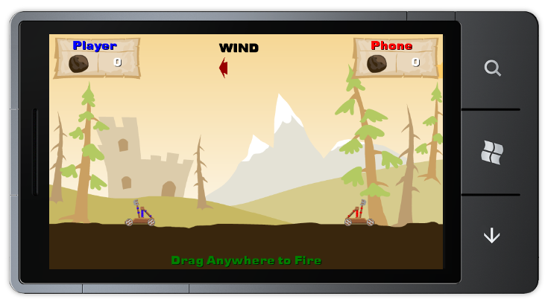
Figure 1. Catapult Wars

Task 1 – Basic game project with game state management
In this task, you will create an XNA Framework game project for the Windows Phone 7 platform and add game state management capabilities to it by incorporating code that is supplied with this lab.
  - Start Visual Studio 2010 or Visual C# 2010 Express.
  - In the File menu, click New Project.
Visual Studio 2010: On the File menu, point to New and then click Project.
  - In the New Project dialog, select the XNA Game Studio 4.0 category and, from the list of installed templates, select Windows Phone Game (4.0); then set the name to CatapultGame and click OK.
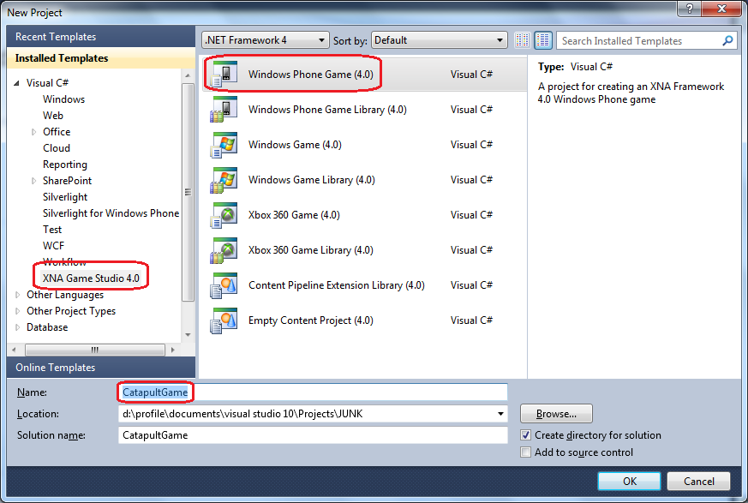
Figure 2. Creating a new Windows Phone Game application project in Microsoft Visual Studio 2010

  - In Solution Explorer, review the structure of the solution generated by the Windows Phone Application template. In Visual Studio, a solution is a container for related projects; in this case, it contains an XNA Game Studio project for Windows Phone 7 named CatapultGame and a related game resource project named CatapultGameContent.
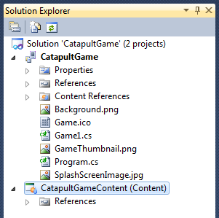
Figure 3. Solution Explorer showing the CatapultGame application

Note: Solution Explorer allows you to view items and perform item management tasks in a solution or a project. To show Solution Explorer, on the View menu, select Other Windows | Solution Explorer; instead, you can also press Ctrl+W, S.
  - The generated project includes a default game implementation that contains the basic XNA Framework game loop. It is located in the Game1.cs file.
  - Open Game1.cs, and change the default name to “CatapultGame.cs”.
  - Rename the main game class (default name "Game1") to "CatapultGame". To rename it, right click on the class name, select Refactor -> Rename
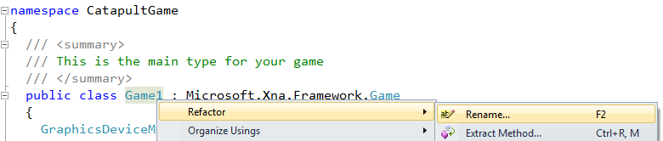
Figure 4
Renaming the main game class
  - In the Rename dialog box, in the New name field, type CatapultGame, and then click OK.
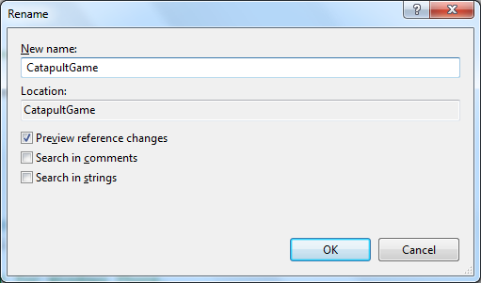
Figure 5. Giving the name to the main game class

  - Review changes suggested by Visual Studio and click Apply.
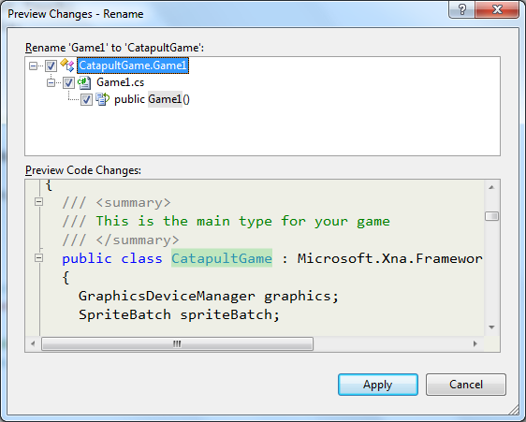
Figure 6. Apply changes to main game class

  - Rename the file to match the new class name. Right-click Game1.cs in Solution Explorer and choose Rename. Give the class the new name CatapultGame.cs.
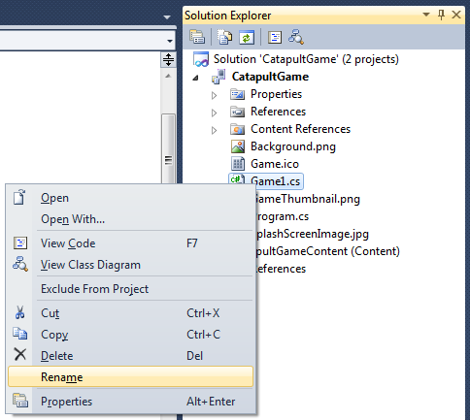
Figure 7. Rename main game class file

  - An XNA Game Studio application typically takes advantage of services provided by the underlying platform or by other libraries. To use this functionality, the application needs to reference the corresponding assemblies that implement these services.
To display the assemblies referenced by the project, expand the References node in Solution Explorer and examine the list. It contains regular XNA Framework assemblies as well as assemblies specific to the Windows Phone platform.
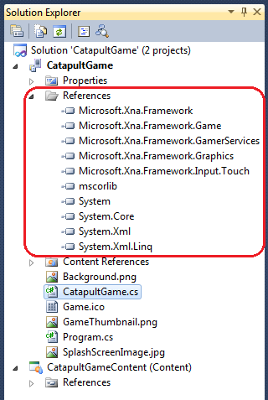
Figure 8. Solution Explorer showing the assemblies referenced by the project

Currently, the application does not do much, but it is ready for its first test run. In this step, you build the application, deploy it to the Windows Phone Emulator, and then execute it to understand the typical development cycle.
  - On the View menu, click Output to open the Output window.
  - Click Build Solution on the Debug menu, or press Shift + F6 to compile the projects in the solution.
Visual Studio 2010: Select Build Solution in the Build menu or press CTRL + SHIFT + B to compile the projects in the solution.

  - Observe the Output window and review the trace messages generated during the build process, including a final message with its outcome.
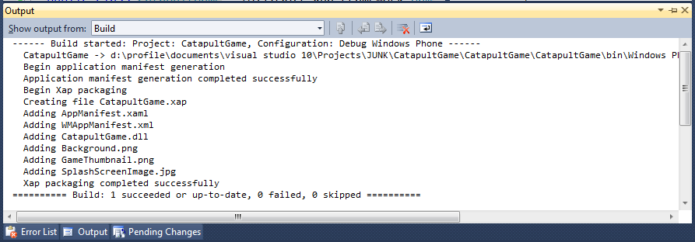
Figure 9. Building the application in Visual Studio

You should not observe any errors at this stage but, if the project were to contain compilation errors, these would appear in the Output window. To deal with these kinds of errors, you can take advantage of the Error List window. This window displays errors, warnings, and messages produced by the compiler in a list that you can sort and filter based on the severity of the error. Moreover, you can double-click an item in the list to automatically open the relevant source code file and navigate to the source of the error.
  - To open the Error List window, on the View menu, point to Other Windows and then click Error List.
Visual Studio 2010: To open the Error List window, on the View menu, click Error List.
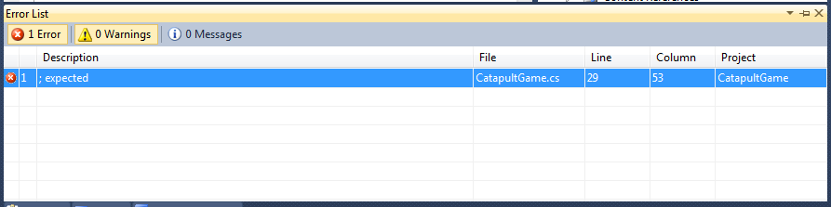
Figure 10. Error List window shows errors during the build process

Note: Be aware that you should not encounter any errors at this stage. This step simply explains how to access the Error List window.
  - Ensure that Windows Phone 7 Emulator is selected in the Select Device drop down list next to the Start Debugging button on the toolbar.
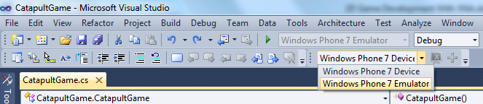
Figure 11. Choosing the target device to deploy the application

Note: When you deploy your application from Visual Studio, you have the option to deploy it to a real device or to the Windows Phone 7 Emulator.
  - Press F5 to launch the application in the Windows Phone 7 Emulator.
Notice that a device emulator window appears and there is a pause while Visual Studio sets up the emulator environment and deploys the image. Once it is ready, the emulator shows the Start page and shortly thereafter, your application appears in the emulator window.
The application will display a simple blue screen with nothing else shown. This is normal for an application in such an early stage.
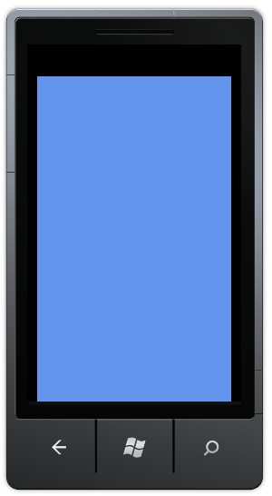
Figure 12. Running the application in the Windows Phone 7 Emulator

Before you create the user interface and program the application logic, there is very little that you can do with the application.

  - Click the Stop button in the toolbar to detach the debugger and end the debugging session.
Do not close the emulator window. You can also stop the application by pressing Shift+F5.
  - 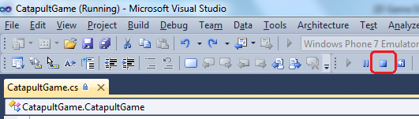
Figure 13. Ending the debugging session

Tip: When you start a debugging session, it takes a perceptible amount of time to set up the emulator environment and launch the application. To streamline your debugging experience, avoid closing the emulator while you work with the source code in Visual Studio. Once the emulator is running, it takes very little time to stop the current session, edit the source code, and then build and deploy a new image of your application to start a new debugging session.
Now that our initial game can run on its own, it is time to add game state management capabilities to it. This will help us in the next task when we start adding screens and menus to the game.
  - In Solution Explorer, right-click CatapultGame, and then point to Add and click New folder.
This step adds a project folder for the game state management code.
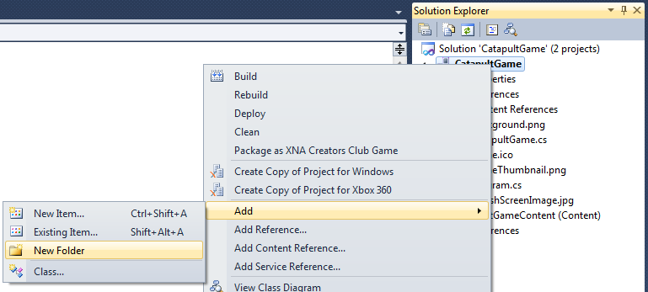
Figure 14. Adding a new project folder

  - Name the newly created folder ScreenManager.
  - Select the ScreenManager folder and add all existing files from the lab installation folder under Assets\Code\ScreenManager. To add existing items, right-click ScreenManager in tSolution Explorer, and then point to Add and click Existing items.
A file selection dialog box will appear.
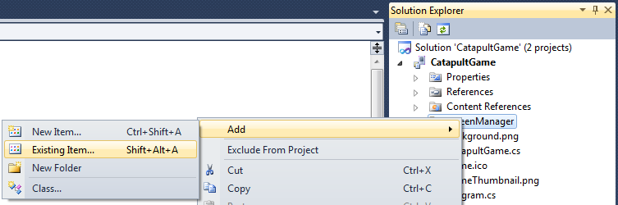
Figure 15. Adding existing items to the project

  - Navigate to the path specified in the previous step, select all source files, and click the Add button.
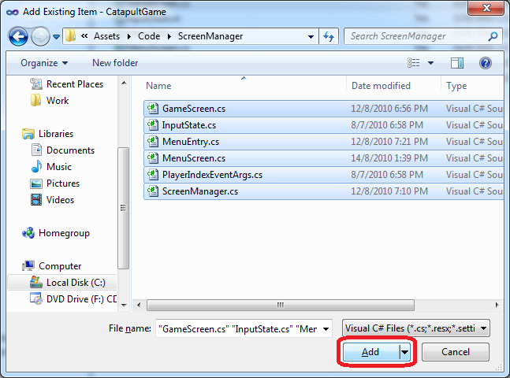
Figure 16. Adding the ScreenManager source files to the project

Note: All the game resources and sample code are provided in the lab installation folder in the following locations:
{LAB_PATH}\Assets\Code – all CSharp code files
{LAB_PATH}\Assets\Media – all graphics, fonts and sounds

Note: The code added in this step implements the Windows Phone Game State Management sample for creating XNA Game Studio menus and screens. It is recommended that you review this sample to better understand it. The complete sample can be found at: http://creators.xna.com/en-US/sample/phonegamestatemanagement
Note that the code has been slightly altered for this lab.
  - Review Solution Explorer.
Your view of Solution Explorer should look like Figure 17.
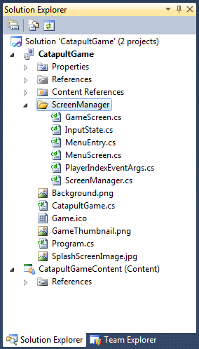
Figure 17. Solution Explorer after adding the ScreenManager folder and code

  - Build the solution again; it should compile without any errors.
There is no point in running the application again as we have not yet altered it in any perceptible way.

Task 2 – Basic game rendering
Having laid the groundwork for adding screens in the previous task, we can add the most important screen in the game—the gameplay screen. This will introduce you to the use of resources and the ScreenManager class. The real focus of this task is to add most of the initial rendering code to the game. We also delve into gameplay logic, where necessary, and implement very basic versions of some of the game classes.
Resources (or assets) are used by games to present the game or enhance the game experience. Resources can be of many types: images, textures, sounds, and so on. This lab provides you with a number of such resources to help you make a complete game.
  - Add the lab’s resources to the game resource project.
All resources are located in the lab installation folder under Assets\Media. While it is possible to add the resources using the technique seen in the previous task, the resource files for this lab are arranged in a directory tree structure that is helpful to preserve.
  - Navigate to the folder specified in the previous step using Windows Explorer, select all three folders and then drag & drop them into the CatapultGameContent project node in Solution Explorer.
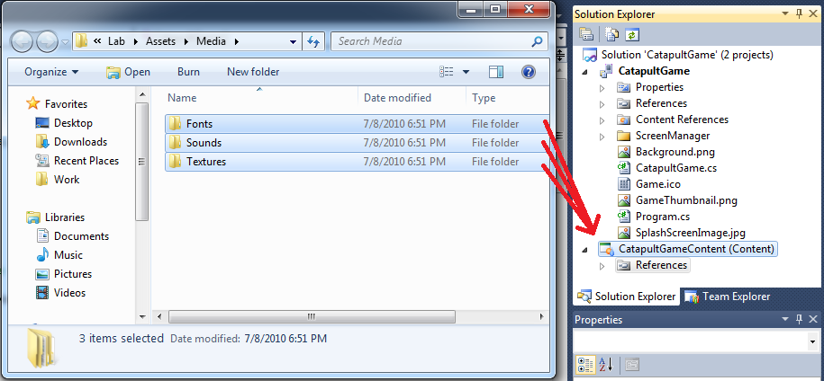
Figure 18. Adding the resource folders into the content project

Note: This drag & drop action is to be performed between applications. The drag operation begins in Windows Explorer, and the concluding drop operation is to CatapultGameContent in the Visual Studio.

Resources can be created in many different ways and stored in many different file formats, and resources tend to change frequently in the course of game development. So, the Content Pipeline is designed to help you include such art assets in your game easily and automatically. An artist working on a car model can add the resulting file to the XNA Game Studio project in the manner just demonstrated and assign the model a name. The Content Pipeline interprets the correct importer and content processor for the model based on the file type. If necessary, you can change the importer and processor used. (For further explanation about importers and content processors, see “2D Asset Types” on creators.xna.com.) Then, a developer who wants to use the car can simply load it by name. This simple flow lets the artist focus on creating assets and the developer on using them, without either having to spend time worrying about content transformation.
The XNA Content Pipeline is activated as part of the build process in your XNA Game Studio project. You just add the resource to your project, and when you compile it, the data is imported and converted into an XNB (XNA Binary) file using a Content Importer. This XNB file is automatically generated for the desired platform.
While the built-in content importers and processors support many common asset types, you can develop and use custom importers and processors; you can also incorporate importers and processors created by third parties to support additional asset types.
Some of the standard Content Importers support the following file types (partial list):
Autodesk FBX format (.fbx)
DirectX Effect file format (.fx)
Font description specified in a .spritefont file
Texture file. The following types are supported: .bmp, .dds, .dib, .hdr, .jpg, .pfm, .png, .ppm, and .tga
Game audio specified in the Microsoft Cross-Platform Audio Creation Tool (XACT) format (.xap), or in wave file format (.wav).

  - Examine Solution Explorer to see that it is similar to Figure 19.
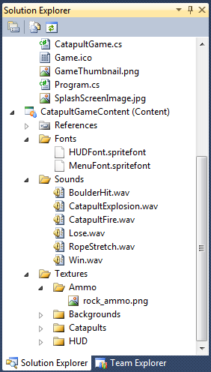
Figure 19. The content project with some of its folders expanded

  - Modify the properties of one of the newly added resources. Under CatapultGameContent, expand Textures, then expand Catapults and select AnimationDefs.xml. To view the file’s properties, right-click it, and the click Properties. In the properties window, expand the Advanced section and change the Build Action property to None and the Copy to Output Directory property to Copy if newer. We perform this change because we do not need this file to be compiled and processed into another format. We will be interpreting it directly. Consult the following screenshots in Figure 20.
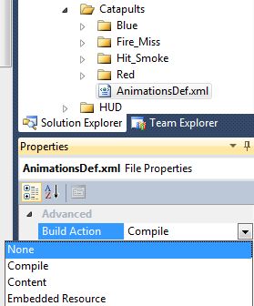
Figure 20. Changing a file’s properties

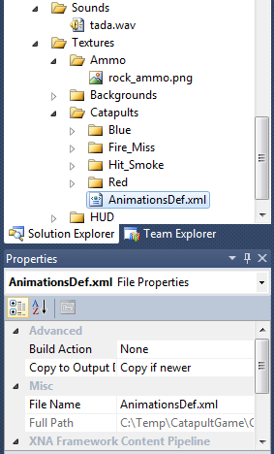
Figure 21. The file after changing its properties

  - This is the time to add the very first screen to our project. Add a folder to the CatapultGame project and call it “Screens”. You will use this project folder to store all game screen classes.
Before we start implementing the gameplay screen, let us review its general architecture.
GameplayScreen and Game Classes
Technically, the game’s update and drawing logic is contained in the GameplayScreen class. However, the GameplayScreen itself does not directly handle all of the work, as some of the work is the responsibility of the relevant game classes.
Let us review some of the game classes and their intended purpose:
Player: The player class represents one of the two players participating in the game and is responsible for drawing each player’s associated catapult on the screen. Two different sub-classes of the Player class actually represent each of the players.
The Human class represents the human player and contains additional logic for handling input and providing visual feedback, while the AI class represents the computer player and will contain additional logic for automatically aiming and firing at the opposing human player.
Catapult: The catapult class encapsulates all the drawing and logic related to one of the catapults in the game. The class keeps track of its associated catapult’s state and animates it according to that state.
Projectile: This class represents a projectile fired by one of the catapults. It is responsible for rendering the projectile and updating its position, but not for determining whether the projectile has hit anything, because this is the job of the Catapult class.
Animation: A helper class for displaying animations.
AudioManager: A helper class for playing sounds.

  - Add a new class to the CatapultGame project and name it “GameplayScreen”. To do this, right-click the Screens folder created in the previous step, and then point to Add and then click Class:
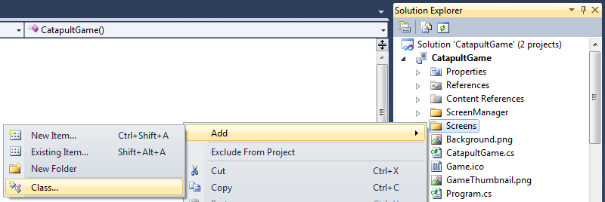
Figure 22. Adding a new class to the project

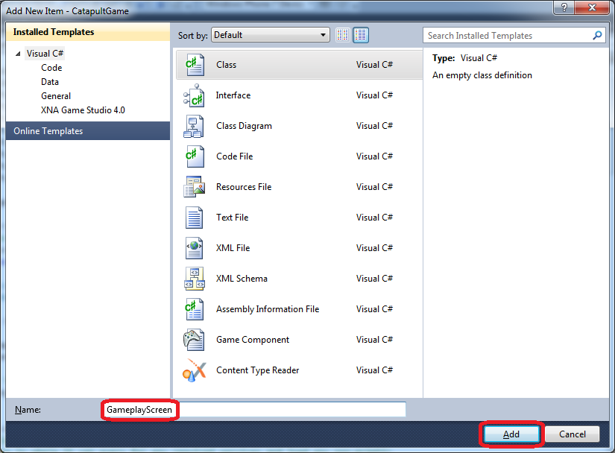
Figure 23. Giving the new class a name

  - Open the new class file and see that it only contains some basic "using" statements and the class definition. Add the following "using" statements at the top of the file.
You can copy & paste directly from the following code:
C#
using Microsoft.Xna.Framework;
using Microsoft.Xna.Framework.Graphics;
using Microsoft.Xna.Framework.Audio;
using System.IO.IsolatedStorage;
using System.IO;
using Microsoft.Xna.Framework.Input;
using Microsoft.Xna.Framework.Input.Touch;
using GameStateManagement;
The complexity of the gameplay screen necessitates the many using statements in the preceding code. The GameplayScreen class will eventually be capable of playing sounds, displaying graphics, and responding to user input.
  - Change the new class to derive from the GameScreen class (the GameScreen class is defined in the class files we previously added to the ScreenManager folder). Also, change the namespace under which the class is defined to "CatapultGame":
C#
namespace CatapultGame
{
class GameplayScreen : GameScreen
{
}
}
Note: From this point forward, whenever creating a new class, always change its namespace to "CatapultGame".
  - Add the following field definitions to the class. We use these fields for loading the textures/fonts used to draw the screen (though some will not be used until much later in the exercise) and also to position some of the assets on the screen:
C#
// Texture Members
Texture2D foregroundTexture;
Texture2D cloud1Texture;
Texture2D cloud2Texture;
Texture2D mountainTexture;
Texture2D skyTexture;
Texture2D hudBackgroundTexture;
Texture2D ammoTypeTexture;
Texture2D windArrowTexture;
Texture2D defeatTexture;
Texture2D victoryTexture;
SpriteFont hudFont;

// Rendering members
Vector2 cloud1Position;
Vector2 cloud2Position;
  - Create a new method and name it “LoadAssets”. This method loads the gameplay screen’s resources and initialize some of its variables:
C#
public void LoadAssets()
{
// Load textures
foregroundTexture =
Load<Texture2D>("Textures/Backgrounds/gameplay_screen");
cloud1Texture = Load<Texture2D>("Textures/Backgrounds/cloud1");
cloud2Texture = Load<Texture2D>("Textures/Backgrounds/cloud2");
mountainTexture = Load<Texture2D>("Textures/Backgrounds/mountain");
skyTexture = Load<Texture2D>("Textures/Backgrounds/sky");
defeatTexture = Load<Texture2D>("Textures/Backgrounds/defeat");
victoryTexture = Load<Texture2D>("Textures/Backgrounds/victory");
hudBackgroundTexture = Load<Texture2D>("Textures/HUD/hudBackground");
windArrowTexture = Load<Texture2D>("Textures/HUD/windArrow");
ammoTypeTexture = Load<Texture2D>("Textures/HUD/ammoType");
// Load font
hudFont = Load<SpriteFont>("Fonts/HUDFont");

// Define initial cloud position
cloud1Position = new Vector2(224 - cloud1Texture.Width, 32);
cloud2Position = new Vector2(64, 90);
}
  - The GameScreen class defines some core game functionality matching the three states described in the exercise preface: LoadContent, Update, and Draw. Override the base class’s LoadContent functionality:
C#
public override void LoadContent()
{
LoadAssets();

base.LoadContent();
}
You may wonder why we did not simply place the code from the “LoadAssets” method inside the preceding override. The reason is that the asset loading operation is rather lengthy, and in the next exercise, we see how we can introduce a loading prompt so that the game does not appear unresponsive. For that purpose, we want to be able to load the assets independently of the gameplay screen’s own LoadContent override.
  - Override the Draw method so that the gameplay screen will be able to draw itself onto the screen:
C#
public override void Draw(GameTime gameTime)
{
float elapsedTime = (float)gameTime.ElapsedGameTime.TotalSeconds;

ScreenManager.SpriteBatch.Begin();

// Render all parts of the screen
DrawBackground();
// DrawComputer(gameTime);
// DrawPlayer(gameTime);
// DrawHud();

ScreenManager.SpriteBatch.End();
}
Notice that the Draw method is implemented using several helper methods which draw different aspects of the game. Most of them are currently commented out; we deal with them later in the exercise.
When this method is called, the gameTime argument contains the time that passed since the last call to Draw was made.
  - Add the DrawBackground helper method which draws the various background elements:
C#
private void DrawBackground()
{
// Clear the background
ScreenManager.Game.GraphicsDevice.Clear(Color.White);

// Draw the Sky
ScreenManager.SpriteBatch.Draw(skyTexture, Vector2.Zero, Color.White);

// Draw Cloud #1
ScreenManager.SpriteBatch.Draw(cloud1Texture,
cloud1Position, Color.White);

// Draw the Mountain
ScreenManager.SpriteBatch.Draw(mountainTexture,
Vector2.Zero, Color.White);

// Draw Cloud #2
ScreenManager.SpriteBatch.Draw(cloud2Texture,
cloud2Position, Color.White);

// Draw the Castle, trees, and foreground
ScreenManager.SpriteBatch.Draw(foregroundTexture,
Vector2.Zero, Color.White);
}
This code simply draws the game’s background image to the screen. The code uses the SpriteBatch class from the Microsoft.Xna.Framework.Graphics namespace to draw to the graphics device. It enables a group of sprites (2D graphics) to be drawn quickly by reusing similar rendering settings.
It is now possible for a user to see the gameplay screen, but we must first connect it to the rest of the game. In order to accomplish that, we revisit some of our code from exercise 1.
  - The gameplay screen can now be made visible. To do that, we are required to alter the game class CatapultGame. Open the CatapultGame.cs file from the solution explorer and delete all content inside the CatapultGame class (but not the defined namespace or the using statements). To clarify, make sure the class looks like the following:
C#
public class CatapultGame : Game
{
}
  - Add the following using statement at the top of the class file:
C#
using GameStateManagement;
  - Add a pair of variable declarations to the beginning of the class:
C#
public class CatapultGame : Game
{
GraphicsDeviceManager graphics;
ScreenManager screenManager;
}
  - Now add a constructor to the class which will add the gameplay screen to the screen manager:
C#
public CatapultGame()
{
graphics = new GraphicsDeviceManager(this);
Content.RootDirectory = "Content";

// Frame rate is 30 fps by default for Windows Phone.
TargetElapsedTime = TimeSpan.FromTicks(333333);

//Create a new instance of the Screen Manager
screenManager = new ScreenManager(this);
Components.Add(screenManager);

//Switch to full screen for best game experience
graphics.IsFullScreen = true;

// TODO: Start with menu screen
screenManager.AddScreen(new GameplayScreen(), null);

// AudioManager.Initialize(this);
}

Note the “TODO” marker comment in the preceding code. In the next exercise, we change the code directly below it, which adds the gameplay screen to the screen manager, to add a menu screen as the initial screen instead.
Also, note that the constructor also contains a commented-out initialization of an “AudioManager” class. We will deal with this class in the next exercise (and un-comment the relevant code to initialize it).
  - Build the project and deploy it. Once the game starts, you should see a screen like that in Figure 24.
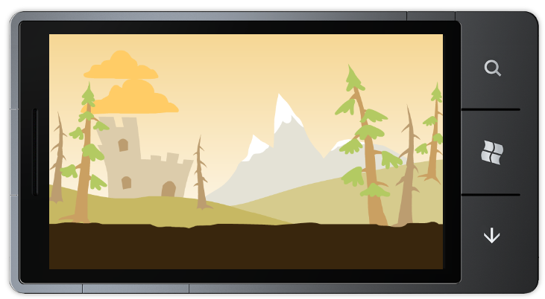
Figure 24. First look at the gameplay screen

At this point, the gameplay screen is somewhat barren, so next we add the Heads-up-display (HUD) for the game. The HUD is the portion of the game’s interface that displays vital information to the user such as the current score.
However, we also need some additional variables to keep track of the information we are about to display, and this is a great opportunity to introduce some of the game classes in order to encapsulate some of the information.
Our first task, therefore, will be to create basic versions of the Player class and its two sub-classes: Human and AI.
  - Create a new project folder under the CatapultGame project and name it Players.
  - Create a new class under the Players project folder and name it Player.
  - At the top of the newly created class file, add the following using statements:
C#
using Microsoft.Xna.Framework;
using Microsoft.Xna.Framework.Graphics;
  - Since the player will eventually be responsible for drawing its associated catapult, it could be considered a game component that can be drawn to the screen. Change the Player class to inherit from the DrawableGameComponent class, and also make it internal since it will eventually contain some data which is internal to the game:
C#
internal class Player : DrawableGameComponent
{
}
Note: Remember to change class’s namespace to CatapultGame.
DrawableGameComponent is a game component that is notified when it needs to draw itself. For more information about this class, see the documentation on MSDN (http://msdn.microsoft.com/en-us/library/microsoft.xna.framework.drawablegamecomponent.aspx).
  - Add the following variable declarations to the Player class:
C#
protected CatapultGame curGame;
protected SpriteBatch spriteBatch;

// Constants used for calculating shot strength
public const float MinShotStrength = 150;
public const float MaxShotStrength = 400;

// Public variables used by Gameplay class
// TODO enable this: public Catapult Catapult;
public int Score { get; set; }
public string Name { get; set; }
These variables will give the Player class access to the game object and to a SpriteBatch that can be used for visual output, and will allow it to keep track of the player’s score and name. Notice the commented-out member variable, Catapult, which represents the catapult associated with the player. We restorethe Catapult member at a later point. Also notice the two constants defined, which are used later to perform some calculations related to firing projectiles.
  - Add a set of initialization methods for the Player class. Two of the methods are constructors and the third is an override of the DrawableGameComponent’s Initialize method, which is typically used for loading resources required by the component before displaying it:
C#
public Player(Game game)
: base(game)
{
curGame = (CatapultGame)game;
}

public Player(Game game, SpriteBatch screenSpriteBatch)
: this(game)
{
spriteBatch = screenSpriteBatch;
}

public override void Initialize()
{
Score = 0;

base.Initialize();
}
  - Add a new class under the Player project folder and name it Human.
  - Add the following using statements to the top of the newly created class file:
C#
using Microsoft.Xna.Framework;
using Microsoft.Xna.Framework.Graphics;
using Microsoft.Xna.Framework.Input.Touch;
  - Change the Human class to inherit from the Player class:
C#
class Human : Player
{
}
  - Add the following constructors inside the Human class:
C#
public Human(Game game)
: base(game)
{
}

public Human(Game game, SpriteBatch screenSpriteBatch)
: base(game, screenSpriteBatch)
{
// TODO: Initialize catapult
}
We will later initialize the player’s catapult as part of the second constructor.
  - Add a new class under the Players project folder and name it AI.
  - Add the following using statements to the top of the new class file:
C#
using Microsoft.Xna.Framework;
using Microsoft.Xna.Framework.Graphics;
  - Change the AI class to inherit from the Player class:
C#
class AI : Player
{
}
  - Add the following constructors inside the AI class:
C#
public AI(Game game)
: base(game)
{
}

public AI(Game game, SpriteBatch screenSpriteBatch)
: base(game, screenSpriteBatch)
{
// TODO: Initialize catapult
}
Now that our basic versions of the player classes are ready, it is time to utilize them in GameplayScreen.
  - Open the file GameplayScreen.cs located inside the Screens project folder and add additional variable definitions to the GameplayScreen class. Place them just under the existing variable definitions (old code has been colored gray):
C#
...
Vector2 cloud1Position;
Vector2 cloud2Position;

Vector2 playerHUDPosition;
Vector2 computerHUDPosition;
Vector2 windArrowPosition;

// Gameplay members
Human player;
AI computer;
Vector2 wind;
bool changeTurn;
bool isHumanTurn;
bool gameOver;
Random random;
const int minWind = 0;
const int maxWind = 10;

// Helper members
bool isDragging;
Most of these new variables are not immediately useful. They will come into play as we add more game logic.
  - Revise the GameplayScreen class’s LoadAssets method by adding additional initialization as shown in the following code:
C#
...
hudFont = Load<SpriteFont>("Fonts/HUDFont");

// Define initial cloud position
cloud1Position = new Vector2(224 - cloud1Texture.Width, 32);
cloud2Position = new Vector2(64, 90);

// Define initial HUD positions
playerHUDPosition = new Vector2(7, 7);
computerHUDPosition = new Vector2(613, 7);
windArrowPosition = new Vector2(345, 46);

// Initialize human & AI players
player = new Human(ScreenManager.Game, ScreenManager.SpriteBatch);
player.Initialize();
player.Name = "Player";

computer = new AI(ScreenManager.Game, ScreenManager.SpriteBatch);
computer.Initialize();
computer.Name = "Phone";

// TODO: Initialize enemy definitions
}
Notice that we have left a placeholder in the code where future code will designate the human and AI players as enemies.
  - Revise the GameplayScreen class’s LoadContent override so that it looks like the following:
C#
public override void LoadContent()
{
LoadAssets();

base.LoadContent();

// Start the game
Start();
}
  - Add the Start helper methods, which deals with initializations directly related to the beginning of the game:
C#
void Start()
{
// Set initial wind direction
wind = Vector2.Zero;

isHumanTurn = false;
changeTurn = true;
// computer.Catapult.CurrentState = CatapultState.Reset;
}
The line that is currently commented out in the preceding code will later integrate with other game logic in order to properly set up the game’s turn cycle.
  - Add a pair of methods to the GameplayScreen class. These methods will be used to draw text to the screen with a shadow effect:
C#
// A simple helper to draw shadowed text.
void DrawString(SpriteFont font, string text, Vector2 position, Color color)
{
ScreenManager.SpriteBatch.DrawString(font, text,
new Vector2(position.X + 1, position.Y + 1), Color.Black);
ScreenManager.SpriteBatch.DrawString(font, text, position, color);
}

// A simple helper to draw shadowed text.
void DrawString(SpriteFont font, string text, Vector2 position, Color color, float fontScale)
{
ScreenManager.SpriteBatch.DrawString(font, text,
new Vector2(position.X + 1, position.Y + 1),
Color.Black, 0, new Vector2(0, font.LineSpacing / 2),
fontScale, SpriteEffects.None, 0);
ScreenManager.SpriteBatch.DrawString(font, text, position,
color, 0, new Vector2(0, font.LineSpacing / 2),
fontScale, SpriteEffects.None, 0);
}
The preceding helper methods draw shadowed text by drawing two instances of a specified string, one colored black and with a slight offset from the other. The second variation of the method allows scaling of the written text.
  - Change GameplayScreen’s Draw method byrestoring the call to the DrawHud method. The method should now look like this:
C#
public override void Draw(GameTime gameTime)
{
float elapsedTime = (float)gameTime.ElapsedGameTime.TotalSeconds;

ScreenManager.SpriteBatch.Begin();

// Render all parts of the screen
DrawBackground();
// DrawComputer(gameTime);
// DrawPlayer(gameTime);
DrawHud();

ScreenManager.SpriteBatch.End();
}
  - Add the DrawHud method:
C#
void DrawHud()
{
if (gameOver)
{
Texture2D texture;
if (player.Score > computer.Score)
{
texture = victoryTexture;
}
else
{
texture = defeatTexture;
}

ScreenManager.SpriteBatch.Draw(
texture,
new Vector2(ScreenManager.Game.GraphicsDevice.Viewport.Width
/ 2 - texture.Width / 2,
ScreenManager.Game.GraphicsDevice.Viewport.Height
/ 2 - texture.Height / 2),
Color.White);
}
else
{
// Draw Player Hud
ScreenManager.SpriteBatch.Draw(hudBackgroundTexture,
playerHUDPosition, Color.White);
ScreenManager.SpriteBatch.Draw(ammoTypeTexture,
playerHUDPosition + new Vector2(33, 35), Color.White);
DrawString(hudFont, player.Score.ToString(),
playerHUDPosition + new Vector2(123, 35), Color.White);
DrawString(hudFont, player.Name,
playerHUDPosition + new Vector2(40, 1), Color.Blue);

// Draw Computer Hud
ScreenManager.SpriteBatch.Draw(hudBackgroundTexture,
computerHUDPosition, Color.White);
ScreenManager.SpriteBatch.Draw(ammoTypeTexture,
computerHUDPosition + new Vector2(33, 35), Color.White);
DrawString(hudFont, computer.Score.ToString(),
computerHUDPosition + new Vector2(123, 35), Color.White);
DrawString(hudFont, computer.Name,
computerHUDPosition + new Vector2(40, 1), Color.Red);

// Draw Wind direction
string text = "WIND";
Vector2 size = hudFont.MeasureString(text);
Vector2 windarrowScale = new Vector2(wind.Y / 10, 1);
ScreenManager.SpriteBatch.Draw(windArrowTexture,
windArrowPosition, null, Color.White, 0, Vector2.Zero,
windarrowScale, wind.X > 0
? SpriteEffects.None : SpriteEffects.FlipHorizontally, 0);

DrawString(hudFont, text,
windArrowPosition - new Vector2(0, size.Y), Color.Black);
if (wind.Y == 0)
{
text = "NONE";
DrawString(hudFont, text, windArrowPosition, Color.Black);
}

if (isHumanTurn)
{
// Prepare human prompt message
text = !isDragging ?
"Drag Anywhere to Fire" : "Release to Fire!";
size = hudFont.MeasureString(text);
}
else
{
// Prepare AI message
text = "I'll get you yet!";
size = hudFont.MeasureString(text);
}

DrawString(hudFont, text,
new Vector2(
ScreenManager.GraphicsDevice.Viewport.Width / 2 - size.X / 2,
ScreenManager.GraphicsDevice.Viewport.Height - size.Y),
Color.Green);
}
}
Let us review this rather lengthy method.
First, we check to see whether the game is over, drawing a banner for victory or defeat, according to how the game ended.
If the game has not yet ended, we then draw two nearly identical elements portraying the status of both players. Each element is composed of (1) a background image, (2) text depicting the player’s name and score, and (3) a graphical representation of the type of ammunition the player is currently using. (Though our final game will not actually present the player with different types of ammunition, this serves as an extension point for such a feature.)
After drawing both players’ statuses, we draw an indicator that notifies the player of the direction of the wind. The purpose of the wind within the frame of the game is to make it more challenging for the player to aim, because it affects the course of his shot. The wind in the game will blow to the left or right at a varying strength; it may also not blow at all. Instead of representing the wind as a scalar value, it is represented by the “wind” 2D vector. The wind’s X component denotes its direction and its Y component denotes its strength. If we examine the code that draws the wind indicator, we can see that first the word “WIND” is drawn on the display, followed either by an arrow representing the magnitude of the wind that currently blows or by the text “NONE” if there is currently no wind.
Finally, we draw a text prompt at the bottom of the screen. The exact text depends on whether the human player is currently the active player or not, and whether the player is currently in the process of taking a shot.
  - Compile and deploy the project. You should now see the an image like Figure 25.
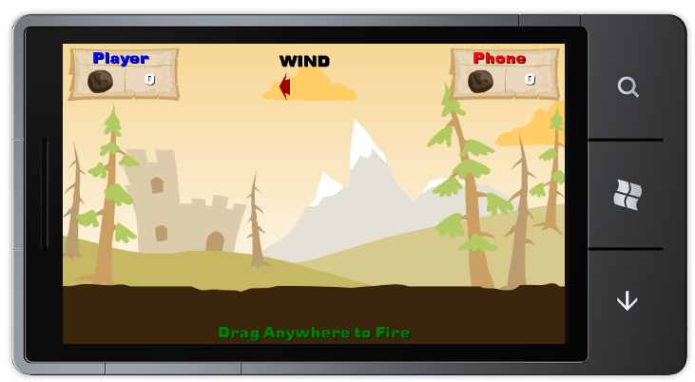
Figure 25. The gameplay screen, with the new HUD

While the game screen now contains much more information, it is still missing a key aspect, which is also the namesake of the game—the catapults. We now focus on adding the Catapult class, which is responsible for drawing the game’s catapults and which will eventually be responsible for much of the game’s logic.
  - Create a new project folder and name it “Catapult”.
  - Add a new class under the Catapult project folder and name it “Catapult”.
  - Add the following using statements to the top of the newly created file:
C#
using Microsoft.Xna.Framework;
using Microsoft.Xna.Framework.Graphics;
using Microsoft.Xna.Framework.Input.Touch;
using Microsoft.Devices;
using System.Xml.Linq;
  - One of the preceding using statements requires us to add an assembly reference to the project. This will allow the project to utilize the services implemented by the referenced assembly. Right click the Referneces node under the project and select Add Reference.
  - In the dialog which appears, find the entry for Microsoft.Devices.Sensors, select it and click the OK button:
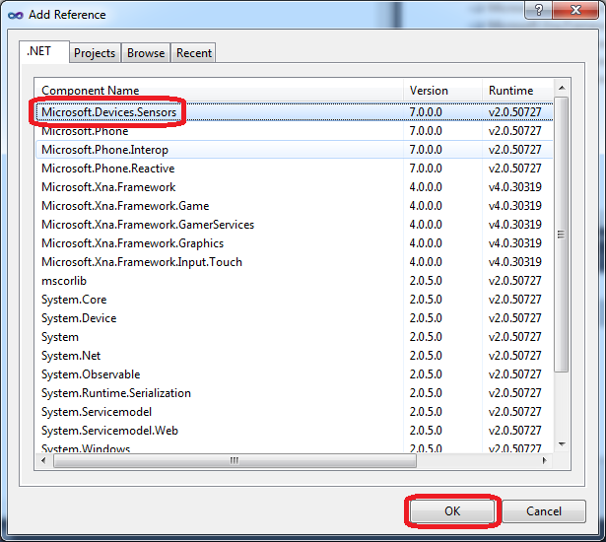
Figure 26. Adding a reference to the project

  - Change the Catapult class to derive from the DrawableGameComponent class, as it logically represents just that – a game component that can be drawn:
C#
class Catapult : DrawableGameComponent
{
}
  - We will eventually want a way to keep track of a catapult’s state. Add the following enum declaration above the class (still inside the same file):
C#
[Flags]
public enum CatapultState
{
Idle = 0x0,
Aiming = 0x1,
Firing = 0x2,
ProjectileFlying = 0x4,
ProjectileHit = 0x8,
Hit = 0x10,
Reset = 0x20,
Stalling = 0x40
}
The preceding enum will make it possible for a catapult to have more than one state at any given time by using binary values that can be stored and retrieved independently of the other values. This type of enum is known as a bitmask.
  - Add the following variable declarations to the Catapult class:
C#
// MARK: Fields start
CatapultGame curGame = null;

SpriteBatch spriteBatch;
Texture2D idleTexture;
string idleTextureName;

bool isAI;

SpriteEffects spriteEffects;
// MARK: Fields end
Now the class can store its associated game, a SpriteBatch with which to display assets, and a texture which shows the catapult in its idle state. We also added a variable to represent whether the catapult is AI controlled or human controlled and an additional rendering variable we will not immediately use.
  - Add the following properties and backing fields to the class. One will be used to represent the catapult’s position, and another to represent the catapult’s state:
C#
Vector2 catapultPosition;
public Vector2 Position
{
get
{
return catapultPosition;
}
}

CatapultState currentState;
public CatapultState CurrentState
{
get { return currentState; }
set { currentState = value; }
}
  - Add the following constructors to the catapult class:
C#
public Catapult(Game game)
: base(game)
{
curGame = (CatapultGame)game;
}

public Catapult(Game game, SpriteBatch screenSpriteBatch,
string IdleTexture,
Vector2 CatapultPosition, SpriteEffects SpriteEffect, bool IsAI)
: this(game)
{
idleTextureName = IdleTexture;
catapultPosition = CatapultPosition;
spriteEffects = SpriteEffect;
spriteBatch = screenSpriteBatch;
isAI = IsAI;

// splitFrames = new Dictionary<string, int>();
// animations = new Dictionary<string, Animation>();
}
The second constructor contains some lines that are commented out, which refer to members that we add at a later stage.
  - In the Catapult class, override the DrawableGameComponent’s Initialize method:
C#
public override void Initialize()
{
// Define initial state of the catapult
currentState = CatapultState.Idle;

// Load the idle texture
idleTexture = curGame.Content.Load<Texture2D>(idleTextureName);

base.Initialize();
}
  - Finally, we override the Draw method so that the Catapult can be drawn to the screen:
C#
public override void Draw(GameTime gameTime)
{
spriteBatch.Draw(idleTexture, catapultPosition, null, Color.White,
0.0f, Vector2.Zero, 1.0f,
spriteEffects, 0);
base.Draw(gameTime);
}
The catapults can now be drawn, but in order for that to actually happen, we need to revisit the player classes and the gameplay screen.
  - Open the Player.cs file and restore the field definition for the “Catapult” field. The relevant portion of the file should now look like this:
C#
...
protected CatapultGame curGame;
protected SpriteBatch spriteBatch;

// Public variables used by Gameplay class
public Catapult Catapult { get; set; }
public int Score;
public string Name;
...
  - Override the Draw method in the Player class:
C#
public override void Draw(GameTime gameTime)
{
// Draw related catapults
Catapult.Draw(gameTime);
base.Draw(gameTime);
}
  - Open the Human.cs file and locate the TODO marker we have left in the Human class’s constructor. Change it so that the constructor would look like the following:
C#
public Human(Game game, SpriteBatch screenSpriteBatch)
: base(game, screenSpriteBatch)
{
Catapult = new Catapult(game, screenSpriteBatch,
"Textures/Catapults/Blue/blueIdle/blueIdle",
new Vector2(140, 332), SpriteEffects.None, false);
}
  - Override the base class’s Initialize method:
C#
public override void Initialize()
{
// TODO: Load textures

Catapult.Initialize();

base.Initialize();
}
Notice that we have left a placeholder where we will later load additional textures used by the Human class.
  - Open the AI.cs file and locate the TODO marker we have left in the AI class’s constructor. Change it so that the constructor would look as follows:
C#
public AI(Game game, SpriteBatch screenSpriteBatch)
: base(game, screenSpriteBatch)
{
Catapult = new Catapult(game, screenSpriteBatch,
"Textures/Catapults/Red/redIdle/redIdle",
new Vector2(600, 332), SpriteEffects.FlipHorizontally,
true);
}
  - Override the base class’s Initialize method:
C#
public override void Initialize()
{
// TODO: Additional initialization

Catapult.Initialize();

base.Initialize();
}
Notice that we have left a placeholder where we will later perform further initialization.
  - Open the GameplayScreen.cs file and add the DrawComputer and DrawPlayer helper methods to the GameplayScreen class:
C#
void DrawPlayer(GameTime gameTime)
{
if (!gameOver)
player.Draw(gameTime);
}

void DrawComputer(GameTime gameTime)
{
if (!gameOver)
computer.Draw(gameTime);
}
  - Finally, we must make the GameplayScreen class render both players. Navigate to the “Draw” method and remove the comments on the lines which call the “DrawComputer” and “DrawPlayer” helper methods. The relevant portion of the code should now look like this:
C#
...
DrawBackground();
DrawComputer(gameTime);
DrawPlayer(gameTime);
DrawHud();
...
  - Compile and deploy the project. After navigating to the game screen, the catapults should now be visible, as shown in Figure 27.
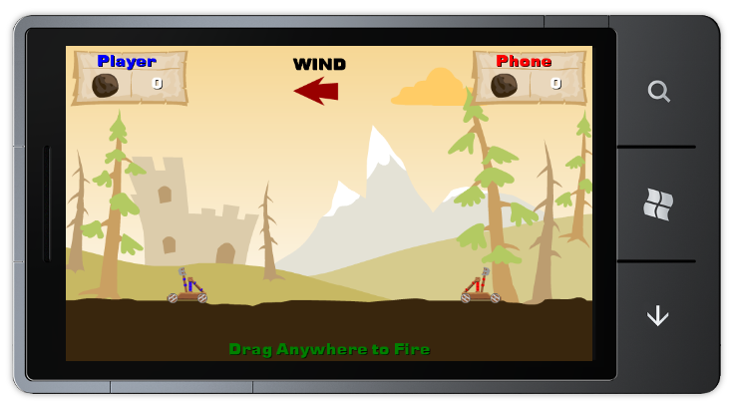
Figure 27. The catapults can now be seen

This concludes the first task of this exercise. During the next task we will implement the game’s logic; at this point, the game merely draws its various elements to the screen.

Task 3 – Game logic
In the course of this task, we add many elements that are still missing from the game. We add a turn cycle that alternates between the human and computer players, giving each a chance to take a shot at the other player. This includes adding projectiles and their associated physics, handling user input, writing the AI logic and so on.
  - We start by creating a class to represent the catapult projectiles. Both players fire projectiles, and the projectiles need to behave in accordance to the laws of physics, taking the wind into account as well. Add a new class under the “Catapult” folder and name it Projectile.
  - Add the following using statements to the top of the newly created file:
C#
using Microsoft.Xna.Framework;
using Microsoft.Xna.Framework.Graphics;
  - As the projectile represents an entity that will be drawn on screen, change the Projectile class to inherit from the DrawableGameComponent class.
C#
class Projectile : DrawableGameComponent
{
}
Note: Do not forget to alter the new class’s namespace as we have done previously.
  - Add the following field and property definitions to the Projectile class:
C#
SpriteBatch spriteBatch;
Game curGame;
Random random;

// Textures for projectile
string textureName;
// Position and speed of projectile
Vector2 projectileVelocity = Vector2.Zero;
float projectileInitialVelocityY;
Vector2 projectileRotationPosition = Vector2.Zero;
float projectileRotation;
float flightTime;
bool isAI;
float hitOffset;
float gravity;

Vector2 projectileStartPosition;
public Vector2 ProjectileStartPosition
{
get
{
return projectileStartPosition;
}
set
{
projectileStartPosition = value;
}
}

Vector2 projectilePosition = Vector2.Zero;
public Vector2 ProjectilePosition
{
get
{
return projectilePosition;
}
set
{
projectilePosition = value;
}
}

// Gets the position where the projectile hit the ground.
// Only valid after a hit occurs.
public Vector2 ProjectileHitPosition { get; private set; }

Texture2D projectileTexture;
public Texture2D ProjectileTexture
{
get
{
return projectileTexture;
}
set
{
projectileTexture = value;
}
}
Most of the preceding fields and properties have names that make it possible to deduce their purpose, but this will become clearer as we implement more of the projectile’s code.
  - Add the following constructors to the Projectile class:
C#
public Projectile(Game game)
: base(game)
{
curGame = game;
random = new Random();
}

public Projectile(Game game, SpriteBatch screenSpriteBatch,
string TextureName, Vector2 startPosition, float groundHitOffset,
bool isAi, float Gravity)
: this(game)
{
spriteBatch = screenSpriteBatch;
projectileStartPosition = startPosition;
textureName = TextureName;
isAI = isAi;
hitOffset = groundHitOffset;
gravity = Gravity;
}
The preceding constructors simply initialize the class’s various fields and are used later by the Catapult class to create new projectiles.
  - Override the DrawableGameComponent’s Initialize method to load the projectile’s texture:
C#
public override void Initialize()
{
// Load a projectile texture
projectileTexture = curGame.Content.Load<Texture2D>(textureName);
}
  - Override the DrawableGameComponent’s Draw method:
C#
public override void Draw(GameTime gameTime)
{
spriteBatch.Draw(projectileTexture, projectilePosition, null,
Color.White, projectileRotation,
new Vector2(projectileTexture.Width / 2,
projectileTexture.Height / 2),
1.0f, SpriteEffects.None, 0);

base.Draw(gameTime);
}
The Draw method is written so that the projectile can be rotated by updating the “projectileRotation” field.
  - Next, add the most important projectile method—the one which updates the projectile while it is in flight:
C#
public void UpdateProjectileFlightData(GameTime gameTime, float wind, float gravity, out bool groundHit)
{
flightTime += (float)gameTime.ElapsedGameTime.TotalSeconds;

// Calculate new projectile position using standard
// formulas, taking the wind as a force.
int direction = isAI ? -1 : 1;

float previousXPosition = projectilePosition.X;
float previousYPosition = projectilePosition.Y;

projectilePosition.X = projectileStartPosition.X +
(direction * projectileVelocity.X * flightTime) +
0.5f * (8 * wind * (float)Math.Pow(flightTime, 2));

projectilePosition.Y = projectileStartPosition.Y -
(projectileVelocity.Y * flightTime) +
0.5f * (gravity * (float)Math.Pow(flightTime, 2));

// Calculate the projectile rotation
projectileRotation += MathHelper.ToRadians(projectileVelocity.X * 0.5f);

// Check if projectile hit the ground or even passed it
// (could happen during normal calculation)
if (projectilePosition.Y >= 332 + hitOffset)
{
projectilePosition.X = previousXPosition;
projectilePosition.Y = previousYPosition;

ProjectileHitPosition = new Vector2(previousXPosition, 332);

groundHit = true;
}
else
{
groundHit = false;
}
}
Let us review the preceding function. First we keep track of the projectile’s total flight time by incrementing the value we have previously stored with the time elapsed since this method was last invoked (provided by the caller using the gameTime parameter). Next, we calculate the projectile’s new position according to its initial velocity, the wind and the effects of gravity. After calculating the projectile’s new position, we rotate it according to how fast it is travelling and check whether it has hit the ground. If the projectile has hit the ground, we alter its position slightly so that it does not appear as if it has entered the ground and store the hit position for later use.
  - Now add one last method to the Projectile class:
C#
public void Fire(float velocityX, float velocityY)
{
// Set initial projectile velocity
projectileVelocity.X = velocityX;
projectileVelocity.Y = velocityY;
projectileInitialVelocityY = projectileVelocity.Y;
// Reset calculation variables
flightTime = 0;
}
The preceding method initializes a projectile after it has been “fired” by one of the catapults.
The projectile class is ready and we can now set our sights on expanding the Catapult class.
  - It is time to add some additional fields and constants to the Catapult class. To make things simple, replace all code between the two comments “// MARK: Fields start” and “// MARK: Fields end”:
C#
// MARK: Fields start
CatapultGame curGame = null;

SpriteBatch spriteBatch;
Random random;

const int winScore = 5;

public bool AnimationRunning { get; set; }
public string Name { get; set; }
public bool IsActive { get; set; }

// In some cases, the game needs to start second animation while first
// animation is still running;
// this variable defines at which frame the second animation should start
// UNCOMMENT: Dictionary<string, int> splitFrames;

Texture2D idleTexture;
// UNCOMMENT: Dictionary<string, Animation> animations;

SpriteEffects spriteEffects;

// Projectile
Projectile projectile;

string idleTextureName;
bool isAI;

// Game constants
const float gravity = 500f;

// State of the catapult during its last update
CatapultState lastUpdateState = CatapultState.Idle;

// Used to stall animations
int stallUpdateCycles;
// MARK: Fields end
You will notice some comments that begin with “UNCOMMENT”. We introduce the fields that these comments hide later, but they are not required yet; one of them relies on a class that we have yet to implement. You might remember that we have already encountered these fields when implementing one of the Catapult class’s constructors.
  - Add the following properties to the Catapult class:
C#
float wind;
public float Wind
{
set
{
wind = value;
}
}

Player enemy;
internal Player Enemy
{
set
{
enemy = value;
}
}

Player self;
internal Player Self
{
set
{
self = value;
}
}

// Describes how powerful the current shot being fired is. The more powerful
// the shot, the further it goes. 0 is the weakest, 1 is the strongest.
public float ShotStrength { get; set; }

public float ShotVelocity { get; set; }

// Used to determine whether the game is over
public bool GameOver { get; set; }
These properties allow a catapult to keep track of the wind, its associated player, the enemy player, the current shot being fired, and the state of the current game.
  - Now alter the Catapult class’s “Initialize” method by adding some code just before the call to base.Initialize. This code will initialize the new fields we have added:
C#
...
// Load the textures
idleTexture = curGame.Content.Load<Texture2D>(idleTextureName);

// Initialize the projectile
Vector2 projectileStartPosition;
if (isAI)
projectileStartPosition = new Vector2(630, 340);
else
projectileStartPosition = new Vector2(175, 340);

// TODO: Update hit offset
projectile = new Projectile(curGame, spriteBatch,
"Textures/Ammo/rock_ammo", projectileStartPosition,
60, isAI, gravity);
projectile.Initialize();

IsActive = true;
AnimationRunning = false;
stallUpdateCycles = 0;

// Initialize randomizer
random = new Random();

base.Initialize();
}
While we have set the projectile’s hit offset to 60 in the preceding code, we will later change this so that the size is relative to the size of the catapult’s graphical asset.
  - Override the Update method in the Catapult class, giving it an opportunity to update its own state and keep track of fired projectiles:
C#
public override void Update(GameTime gameTime)
{
bool isGroundHit;
bool startStall;
CatapultState postUpdateStateChange = 0;

if (gameTime == null)
throw new ArgumentNullException("gameTime");

if (!IsActive)
{
base.Update(gameTime);
return;
}

switch (currentState)
{
case CatapultState.Idle:
// Nothing to do
break;
case CatapultState.Aiming:
if (lastUpdateState != CatapultState.Aiming)
{
// TODO: Play sound

AnimationRunning = true;
if (isAI == true)
{
// TODO: Play animation
stallUpdateCycles = 20;
startStall = false;
}
}

// Progress Aiming "animation"
if (isAI == false)
{
// TODO: Play animation
}
else
{
// TODO: Play animation
// TODO: take “startStall” into account
currentState = (true) ?
CatapultState.Stalling : CatapultState.Aiming;
}
break;
case CatapultState.Stalling:
if (stallUpdateCycles-- <= 0)
{
// We've finished stalling, fire the projectile
Fire(ShotVelocity);
postUpdateStateChange = CatapultState.Firing;
}
break;
case CatapultState.Firing:
// Progress Fire animation
if (lastUpdateState != CatapultState.Firing)
{
// TODO: Play Sounds and animate
}

// TODO: Play animation

// TODO: Fire at the appropriate animation frame
postUpdateStateChange = currentState |
CatapultState.ProjectileFlying;
projectile.ProjectilePosition =
projectile.ProjectileStartPosition;
break;
case CatapultState.Firing | CatapultState.ProjectileFlying:
// Progress Fire animation
// TODO: Play animation

// Update projectile velocity & position in flight
projectile.UpdateProjectileFlightData(gameTime, wind, gravity,
out isGroundHit);

if (isGroundHit)
{
// Start hit sequence
postUpdateStateChange = CatapultState.ProjectileHit;
// TODO: Play animation
}
break;
case CatapultState.ProjectileFlying:
// Update projectile velocity & position in flight
projectile.UpdateProjectileFlightData(gameTime, wind, gravity,
out isGroundHit);
if (isGroundHit)
{
// Start hit sequence
postUpdateStateChange = CatapultState.ProjectileHit;
// TODO: Play animation
}

break;
case CatapultState.ProjectileHit:
// Check hit on ground impact
if (!CheckHit())
{
if (lastUpdateState != CatapultState.ProjectileHit)
{
// TODO: Vibrate device and play sound
}

// TODO: Relate to animation when changing state
postUpdateStateChange = CatapultState.Reset;

// TODO: Update animation
}
else
{
// TODO: Vibrate the device
}

break;
case CatapultState.Hit:
// TODO: only check score when animation is finished
if (enemy.Score >= winScore)
{
GameOver = true;
break;
}

postUpdateStateChange = CatapultState.Reset;

// TODO: Update animation
break;
case CatapultState.Reset:
AnimationRunning = false;
break;
default:
break;
}

lastUpdateState = currentState;
if (postUpdateStateChange != 0)
{
currentState = postUpdateStateChange;
}

base.Update(gameTime);
}

As you can see, the method mainly updates the catapult’s own state and the state of its fired projectile. Notice the many placeholders, which we later use to animate the catapult according to its state, to play sounds, and to cause the device to vibrate.
  - Implement the “CheckHit” method, which appears in the Update method in the preceding code block. This method is responsible for determining whether a projectile has hit one of the catapults:
C#
private bool CheckHit()
{
bool bRes = false;
// Build a sphere around the projectile
Vector3 center = new Vector3(projectile.ProjectilePosition, 0);
BoundingSphere sphere = new BoundingSphere(center,
Math.Max(projectile.ProjectileTexture.Width / 2,
projectile.ProjectileTexture.Height / 2));

// Check Self-Hit - create a bounding box around self
// TODO: Take asset size into account
Vector3 min = new Vector3(catapultPosition, 0);
Vector3 max = new Vector3(catapultPosition + new Vector2(75, 60), 0);
BoundingBox selfBox = new BoundingBox(min, max);

// Check enemy - create a bounding box around the enemy
// TODO: Take asset size into account
min = new Vector3(enemy.Catapult.Position, 0);
max = new Vector3(enemy.Catapult.Position + new Vector2(75, 60), 0);
BoundingBox enemyBox = new BoundingBox(min, max);

// Check self hit
if (sphere.Intersects(selfBox) && currentState != CatapultState.Hit)
{
// TODO: Play self hit sound

// Launch hit animation sequence on self
Hit();
enemy.Score++;
bRes = true;
}
// Check if enemy was hit
else if (sphere.Intersects(enemyBox)
&& enemy.Catapult.CurrentState != CatapultState.Hit
&& enemy.Catapult.CurrentState != CatapultState.Reset)
{
// TODO: Play enemy hit sound

// Launch enemy hit animaton
enemy.Catapult.Hit();
self.Score++;
bRes = true;
currentState = CatapultState.Reset;
}

return bRes;
}
This method simply uses intersection checks built into the XNA Framework to determine whether the projectile intersects with (that is, has hit) a catapult. You will notice placeholders for sound playback and might notice that we once more use constants in place of sizes relative to the catapult asset. We do this only temporarily, as we will later retrieve asset sizes using the Animation game class, which we have yet to implement.
  - Implement the “Hit” method used in the CheckHit method. This method simply updates a catapult to represent the fact it has been hit:
C#
public void Hit()
{
AnimationRunning = true;
// TODO: Start animations
currentState = CatapultState.Hit;
}
  - Now that the catapult has varying states, we create a more sophisticated Draw override, which takes these states into account. Initially, however, it does not do much, because most work will be animating the catapults, something we do not do until the next exercise. Create a new method named “DrawIdleCatapult” as seen in the following code:
C#
private void DrawIdleCatapult()
{
spriteBatch.Draw(idleTexture, catapultPosition, null, Color.White,
0.0f, Vector2.Zero, 1.0f,
spriteEffects, 0);
}
  - Now change the “Draw” override so that it looks like this:
C#
public override void Draw(GameTime gameTime)
{
if (gameTime == null)
throw new ArgumentNullException("gameTime");

switch (lastUpdateState)
{
case CatapultState.Idle:
DrawIdleCatapult();
break;
case CatapultState.Aiming:
// TODO: Handle aiming animation
break;
case CatapultState.Firing:
// TODO: Handle firing animation
break;
case CatapultState.Firing | CatapultState.ProjectileFlying:
case CatapultState.ProjectileFlying:
// TODO: Handle firing animation
projectile.Draw(gameTime);
break;
case CatapultState.ProjectileHit:
// Draw the catapult
DrawIdleCatapult();

// TODO: Handle projectile hit animation
break;
case CatapultState.Hit:
// TODO: Handle catapult destruction animation
// TODO: Handle explosion animation
break;
case CatapultState.Reset:
DrawIdleCatapult();
break;
default:
break;
}

base.Draw(gameTime);
}
  - Add the Fire method, which instructs the Catapult class to fire a projectile:
C#
public void Fire(float velocity)
{
projectile.Fire(velocity, velocity);
}
This concludes our current iteration for the Catapult class. We will now move yet again to the various player classes and expand them further.
  - Open the Player.cs file and add the following two properties to the Player class:
C#
public Player Enemy
{
set
{
Catapult.Enemy = value;
Catapult.Self = this;
}
}

public bool IsActive { get; set; }
  - The last thing to do in the Player class is to override the Update method. This will cause the player’s associated catapult to update:
C#
public override void Update(GameTime gameTime)
{
// Update catapult related to the player
Catapult.Update(gameTime);
base.Update(gameTime);
}
  - Open the AI.cs file and add a new field to the AI class:
C#
Random random;
  - Revise the Initialize method. It should now look like this:
C#
public override void Initialize()
{
//Initialize randomizer
random = new Random();

Catapult.Initialize();

base.Initialize();
}
  - Finally, we will override the Update method in the AI class. This will be used as an opportunity for the computer player to shoot at the human player:
C#
public override void Update(GameTime gameTime)
{
// Check if it is time to take a shot
if (Catapult.CurrentState == CatapultState.Aiming &&
!Catapult.AnimationRunning)
{
// Fire at a random strength
float shotVelocity =
random.Next((int)MinShotStrength, (int)MaxShotStrength);

Catapult.ShotStrength = (shotVelocity / MaxShotStrength);
Catapult.ShotVelocity = shotVelocity;
}
base.Update(gameTime);
}
This concludes all work on the AI class, and we can move on to the Human class. The Human class presents a new challenge, because this is where we will introduce the input handling required to respond to the user’s actions.
  - Open the Human.cs file and add the following fields to the Human class:
C#
GestureSample? prevSample;
GestureSample? firstSample;
public bool isDragging { get; set; }
// Constant for longest distance possible between drag points
readonly float maxDragDelta = (new Vector2(480, 800)).Length();
// Textures & position & spriteEffects used for Catapult
Texture2D arrow;
float arrowScale;

Vector2 catapultPosition = new Vector2(140, 332);
  - Alter the Human class’s second constructor (the one which receives two arguments) to look like the following:
C#
public Human(Game game, SpriteBatch screenSpriteBatch)
: base(game, screenSpriteBatch)
{
Catapult = new Catapult(game, screenSpriteBatch,
"Textures/Catapults/Blue/blueIdle/blueIdle",
catapultPosition, SpriteEffects.None, false);
}
The only change is that we use the field added in the previous step to specify the catapult’s location.
  - Revise the Initialize method. We replace the comment beginning with “TODO” with code that loads the texture used to draw visual feedback for the user:
C#
public override void Initialize()
{
arrow = curGame.Content.Load<Texture2D>("Textures/HUD/arrow");

Catapult.Initialize();

base.Initialize();
}
  - Create a new method in the Human class called HandleInput. This method is used to react to the user’s touch gestures, which are used to shoot at the computer player. It is worth mentioning that this method is not invoked automatically; we will invoke it later from the GameplayScreen.
C#
public void HandleInput(GestureSample gestureSample)
{
// Process input only if in Human's turn
if (IsActive)
{
// Process any Drag gesture
if (gestureSample.GestureType == GestureType.FreeDrag)
{
// If drag just began save the sample for future
// calculations and start Aim "animation"
if (null == firstSample)
{
firstSample = gestureSample;
Catapult.CurrentState = CatapultState.Aiming;
}

// save the current gesture sample
prevSample = gestureSample;

// calculate the delta between first sample and current
// sample to present visual sound on screen
Vector2 delta = prevSample.Value.Position -
firstSample.Value.Position;
Catapult.ShotStrength = delta.Length() / maxDragDelta;
float baseScale = 0.001f;
arrowScale = baseScale * delta.Length();
isDragging = true;
}
else if (gestureSample.GestureType == GestureType.DragComplete)
{
// calc velocity based on delta between first and last
// gesture samples
if (null != firstSample)
{
Vector2 delta = prevSample.Value.Position -
firstSample.Value.Position;
Catapult.ShotVelocity = MinShotStrength +
Catapult.ShotStrength *
(MaxShotStrength - MinShotStrength);
Catapult.Fire(Catapult.ShotVelocity);
Catapult.CurrentState = CatapultState.Firing;
}

// turn off dragging state
ResetDragState();
}
}
}
While lengthy, the preceding method is rather simple. In order to fire, the user will drag a finger across the device’s display and the shot’s strength will be calculated based on the distance between the point where the user first touched the screen to the point where the user lifted the finger from the display. This is exactly what the preceding method is responsible for, all the while updating a variable which will be used to draw visual feedback as the user drags the finger across the display.
  - Create a new method in the Human class called ResetDragState. This method will reset the dragging state of human-controlled catapult.
C#
public void ResetDragState()
{
firstSample = null;
prevSample = null;
isDragging = false;
arrowScale = 0;
Catapult.ShotStrength = 0;
}
  - Finally, we will override the Draw method inside the Human class and add an additional helper method named DrawDragArrow. These methods will display an arrow on screen that depicts the strength of the shot as the user drags a finger across the display:
C#
public override void Draw(GameTime gameTime)
{
if (isDragging)
DrawDragArrow(arrowScale);

base.Draw(gameTime);
}

public void DrawDragArrow(float arrowScale)
{
spriteBatch.Draw(arrow, catapultPosition + new Vector2(0, -40),
null, Color.Blue, 0,
Vector2.Zero, new Vector2(arrowScale, 0.1f), SpriteEffects.None, 0);
}
You may notice how the arrow’s origin is relative to the position of the catapult.
This concludes our update to the game classes at this stage. We now move to the GameplayScreen class to implement the final pieces of game logic.
  - Open the GameplayScreen.cs class, and add the following constructor to the GameplayScreen class:
C#
public GameplayScreen()
{
EnabledGestures = GestureType.FreeDrag |
GestureType.DragComplete |
GestureType.Tap;

random = new Random();
}
This will enable support for drag and tap in the game.
  - Navigate to the “LoadAssets” method and locate the comment “// TODO: Initialize enemy definitions”. Add the following code directly beneath it (the following block shows surrounding code as well, with existing code colored gray as before):
C#
...
computer.Initialize();
computer.Name = "Phone";

// Initialize enemy definitions
player.Enemy = computer;
computer.Enemy = player;
}
  - Override the Update method. This is where we will implement the turn logic:
C#
public override void Update(GameTime gameTime, bool otherScreenHasFocus, bool coveredByOtherScreen)
{
float elapsed = (float)gameTime.ElapsedGameTime.TotalSeconds;

// Check if one of the players reached 5 and stop the game
if ((player.Catapult.GameOver || computer.Catapult.GameOver) &&
(gameOver == false))
{
gameOver = true;

if (player.Score > computer.Score)
{
// TODO: Play sound
}
else
{
// TODO: Play sound
}

base.Update(gameTime, otherScreenHasFocus, coveredByOtherScreen);

return;
}

// If Reset flag raised and both catapults are not animating -
// active catapult finished the cycle, new turn!
if ((player.Catapult.CurrentState == CatapultState.Reset ||
computer.Catapult.CurrentState == CatapultState.Reset) &&
!(player.Catapult.AnimationRunning ||
computer.Catapult.AnimationRunning))
{
changeTurn = true;

if (player.IsActive == true) //Last turn was a human turn?
{
player.IsActive = false;
computer.IsActive = true;
isHumanTurn = false;
player.Catapult.CurrentState = CatapultState.Idle;
computer.Catapult.CurrentState = CatapultState.Aiming;
}
else //It was an AI turn
{
player.IsActive = true;
computer.IsActive = false;
isHumanTurn = true;
computer.Catapult.CurrentState = CatapultState.Idle;
player.Catapult.CurrentState = CatapultState.Idle;
}
}

if (changeTurn)
{
// Update wind
wind = new Vector2(random.Next(-1, 2),
random.Next(minWind, maxWind + 1));

// Set new wind value to the players and
player.Catapult.Wind = computer.Catapult.Wind =
wind.X > 0 ? wind.Y : -wind.Y;
changeTurn = false;
}

// Update the players
player.Update(gameTime);
computer.Update(gameTime);

// Updates the clouds position
UpdateClouds(elapsed);

base.Update(gameTime, otherScreenHasFocus, coveredByOtherScreen);
}
This method is divided into several main segments. We first check whether the game is over, which happens when one of the players reaches a score of five points, and update a flag accordingly. (In the upcoming exercise, we also play appropriate sounds.) We then check whether the current turn is over and reset some fields for the next turn, depending on which type of player has just played (either the human player or the computer player). In addition, assuming a turn has ended, we update the wind. Finally, we ask both players to perform respective updates and change the position of the clouds inside the UpdateClouds helper, which we will implement next.
  - Add a method called UpdateClouds to the GameplayScreen class:
C#
private void UpdateClouds(float elapsedTime)
{
// Move the clouds according to the wind
int windDirection = wind.X > 0 ? 1 : -1;

cloud1Position += new Vector2(24.0f, 0.0f) * elapsedTime *
windDirection * wind.Y;
if (cloud1Position.X > ScreenManager.GraphicsDevice.Viewport.Width)
cloud1Position.X = -cloud1Texture.Width * 2.0f;
else if (cloud1Position.X < -cloud1Texture.Width * 2.0f)
cloud1Position.X = ScreenManager.GraphicsDevice.Viewport.Width;

cloud2Position += new Vector2(16.0f, 0.0f) * elapsedTime *
windDirection * wind.Y;
if (cloud2Position.X > ScreenManager.GraphicsDevice.Viewport.Width)
cloud2Position.X = -cloud2Texture.Width * 2.0f;
else if (cloud2Position.X < -cloud2Texture.Width * 2.0f)
cloud2Position.X = ScreenManager.GraphicsDevice.Viewport.Width;
}
This simply updates the positions of the clouds according to the wind, and causes them to wrap around the screen should they exit its boundaries.
  - Override the HandleInput method. This is used to actually handle the user’s input:
C#
public override void HandleInput(InputState input)
{
if (input == null)
throw new ArgumentNullException("input");

if (gameOver)
{
if (input.IsPauseGame(null))
{
FinishCurrentGame();
}

foreach (GestureSample gestureSample in input.Gestures)
{
if (gestureSample.GestureType == GestureType.Tap)
{
FinishCurrentGame();
}
}

return;
}

if (input.IsPauseGame(null))
{
PauseCurrentGame();
}
else if (isHumanTurn &&
(player.Catapult.CurrentState == CatapultState.Idle ||
player.Catapult.CurrentState == CatapultState.Aiming))
{
// Read all available gestures
foreach (GestureSample gestureSample in input.Gestures)
{
if (gestureSample.GestureType == GestureType.FreeDrag)
isDragging = true;
else if (gestureSample.GestureType == GestureType.DragComplete)
isDragging = false;

player.HandleInput(gestureSample);
}
}
}
The preceding method handles the input that instructs the game to pause or end, using helper methods that we will soon implement, and passes gesture information to the Human class for processing, if it is the player’s turn.
  - Implement the following two methods in the GameplayScreen class. They will be used to pause and end the game:
C#
private void FinishCurrentGame()
{
ExitScreen();
}

private void PauseCurrentGame()
{
// TODO: Display pause screen
}
Notice the preceding placeholder comment beginning with “TODO”. We change that portion of the code later to display a pause screen, which we create during the next exercise.
  - Navigate to the “Start” method in the GameplayScreen class and restore the final line of code. The method should now look like this:
C#
void Start()
{
// Set initial wind direction
wind = Vector2.Zero;

isHumanTurn = false;
changeTurn = true;
computer.Catapult.CurrentState = CatapultState.Reset;
}
  - Compile and deploy the project. The game should now be completely playable, though severely lacking in polish. Having left some placeholders to support the addition of animations, the catapults will actually disappear during various stages of the game. Additionally, once the game ends in either victory or defeat, tapping the display will advance to a blank screen. In the next exercise, we will add sounds and animations to improve the game experience.
Exercise 2: Game polish and menus
In the previous exercise, we implemented a game with playable logic. While the game is fully playable in its current state, the game experience lacks polish. Our first task in this exercise is to improve the game’s presentation by incorporating sound and animation.
Later in the exercise, we add additional elements that are part of the game but are not part of the actual gameplay screen. We add a main menu and an instructions screen, and we give the user the ability to pause the game and display a pause screen.
Task 1 – Polishing the game – Sounds and animations
  - Create a new project folder under the “CatapultGame” project and name it Utility.
  - Create a new class under the “Utility” project folder and name it Animation.
  - Add the following using statements to the beginning of the new class file:
C#
using Microsoft.Xna.Framework;
using Microsoft.Xna.Framework.Graphics;
Note: Remember to keep setting the namespace for new classes to “CatapultGame”.
  - Add the following fields to the Animation class:
C#
// Animation variables
Texture2D animatedCharacter;
Point sheetSize;
Point currentFrame;
public Point FrameSize { get; set; }
The preceding fields allow the animation class to save a texture that serves as the animation strip and also allow tracking of the animation’s dimensions and state.
  - Add the following properties to the Animation class:
C#
public int FrameCount
{
get { return sheetSize.X * sheetSize.Y; }
}

public Vector2 Offset { get; set; }

public int FrameIndex
{
get
{
return sheetSize.X * currentFrame.Y + currentFrame.X;
}
set
{
if (value >= sheetSize.X * sheetSize.Y + 1)
{
throw new InvalidOperationException(
"Specified frame index exeeds available frames");
}

currentFrame.Y = value / sheetSize.X;
currentFrame.X = value % sheetSize.X;
}
}

public bool IsActive { get; private set; }
To clarify the meaning of the preceding properties: The “FrameCount” property simply returns the amount of frames contained in the animation represented by the Animation object. The “Offset” property is used to draw the animation at a specified offset by adding the offset value to the position passed to the existing Draw call. The “FrameIndex” property returns the index of the animation’s current frame or sets it. The “IsActive” property can be used to pause the animation by setting it to false.
  - Add the following constructor to the Animation class:
C#
public Animation(Texture2D frameSheet, Point size,
Point frameSheetSize)
{
animatedCharacter = frameSheet;
FrameSize = size;
sheetSize = frameSheetSize;
Offset = Vector2.Zero;
}
  - Add a new method to the Animation class and name it Update. Note that this method is not an override and will need to be explicitly called in order to advance the animation:
C#
public void Update()
{
if (IsActive)
{
if (FrameIndex >= FrameCount - 1)
{
IsActive = false;
FrameIndex = FrameCount - 1; // Stop at last frame
}
else
{
// Remember that updating "currentFrame" will also
// update the FrameIndex property.

currentFrame.X++;
if (currentFrame.X >= sheetSize.X)
{
currentFrame.X = 0;
currentFrame.Y++;
}
if (currentFrame.Y >= sheetSize.Y)
currentFrame.Y = 0;
}
}
}
The preceding method simply advances the animation by a single frame, stopping the animation if it has reached the final frame.
  - Add the following to Draw methods to the animation class:
C#
public void Draw(SpriteBatch spriteBatch, Vector2 position, SpriteEffects spriteEffect)
{
Draw(spriteBatch, position, 1.0f, spriteEffect);
}

public void Draw(SpriteBatch spriteBatch, Vector2 position, float scale, SpriteEffects spriteEffect)
{
spriteBatch.Draw(animatedCharacter, position + Offset, new Rectangle(
FrameSize.X * currentFrame.X,
FrameSize.Y * currentFrame.Y,
FrameSize.X,
FrameSize.Y),
Color.White, 0f, Vector2.Zero, scale, spriteEffect, 0);
}
The preceding methods simply draw the portion of the animation sheet that matches the current frame, with the second override allowing the animation to be scaled.
  - Add a final method to the Animation class and name it PlayFromFrameIndex. This method is used for playing an animation from a specified frame.
C#
public void PlayFromFrameIndex(int frameIndex)
{
FrameIndex = frameIndex;
IsActive = true;
}
We now have a class that represents an animation and encapsulates its functionality. Next, we add an additional class to support sound playback.
  - Add a new class under the “Utility” project folder and name it AudioManager.
  - Add the following using statements to the beginning of the new class file:
C#
using Microsoft.Xna.Framework;
using Microsoft.Xna.Framework.Audio;
  - We would like this class to be a singleton game component. First, alter the class to inherit from the GameComponent class:
C#
class AudioManager : GameComponent
{
}
  - Add the following field to contain the AudioManager’s singleton instance:
C#
private static AudioManager audioManager = null;
  - Add additional fields to the class:
C#
private SoundEffectInstance musicSound;
private Dictionary<string, SoundEffectInstance> soundBank;
private string[,] soundNames;
The preceding fields are used to maintain sound related data.
  - Add the following constructor to the class:
C#
private AudioManager(Game game)
: base(game) { }
  - Add a method and name it Initialize. This method is used to initialize the singleton instance and register it with the game:
C#
public static void Initialize(Game game)
{
audioManager = new AudioManager(game);

if (game != null)
{
game.Components.Add(audioManager);
}
}
  - Add a new method and name it LoadSounds. This method is responsible for loading a predefined set of sound assets, which we have added to the content project during the first exercise:
C#
public static void LoadSounds()
{
string soundLocation = "Sounds/";
audioManager.soundNames = new string[,] {
{"CatapultExplosion", "catapultExplosion"},
{"Lose", "gameOver_Lose"},
{"Win", "gameOver_Win"},
{"BoulderHit", "boulderHit"},
{"CatapultFire", "catapultFire"},
{"RopeStretch", "ropeStretch"}};

audioManager.soundBank = new Dictionary<string, SoundEffectInstance>();

for (int i = 0; i < audioManager.soundNames.GetLength(0); i++)
{
SoundEffect se = audioManager.Game.Content.Load<SoundEffect>(
soundLocation + audioManager.soundNames[i, 0]);
audioManager.soundBank.Add(
audioManager.soundNames[i, 1], se.CreateInstance());
}
}
  - Add the following methods to the AudioManager class:
C#
public static void PlaySound(string soundName)
{
// If the sound exists, start it
if (audioManager.soundBank.ContainsKey(soundName))
audioManager.soundBank[soundName].Play();
}

public static void PlaySound(string soundName, bool isLooped)
{
// If the sound exists, start it
if (audioManager.soundBank.ContainsKey(soundName))
{
if (audioManager.soundBank[soundName].IsLooped != isLooped)
audioManager.soundBank[soundName].IsLooped = isLooped;

audioManager.soundBank[soundName].Play();
}
}

public static void StopSound(string soundName)
{
// If the sound exists, stop it
if (audioManager.soundBank.ContainsKey(soundName))
audioManager.soundBank[soundName].Stop();
}

public static void StopSounds()
{
var soundEffectInstances = from sound in audioManager.soundBank.Values
where sound.State != SoundState.Stopped
select sound;

foreach (var soundeffectInstance in soundEffectInstances)
soundeffectInstance.Stop();
}

public static void PauseResumeSounds(bool isPause)
{
SoundState state = isPause ? SoundState.Paused : SoundState.Playing;

var soundEffectInstances = from sound in audioManager.soundBank.Values
where sound.State == state
select sound;

foreach (var soundeffectInstance in soundEffectInstances)
{
if (isPause)
soundeffectInstance.Play();
else
soundeffectInstance.Pause();
}
}

public static void PlayMusic(string musicSoundName)
{
// Stop the old music sound
if (audioManager.musicSound != null)
audioManager.musicSound.Stop(true);

// If the music sound exists
if (audioManager.soundBank.ContainsKey(musicSoundName))
{
// Get the instance and start it
audioManager.musicSound = audioManager.soundBank[musicSoundName];
if (!audioManager.musicSound.IsLooped)
audioManager.musicSound.IsLooped = true;
audioManager.musicSound.Play();
}
}
The preceding methods allows playing and stopping the sounds loaded using the LoadSounds method, stopping all currently playing sounds, pausing all currently playing sounds and resuming all currently paused sounds. The final method enables support for background music, and is not used in the course of this exercise.
  - Add a final method to the AudioManager class by overriding the Dispose method:
C#
protected override void Dispose(bool disposing)
{
try
{
if (disposing)
{
foreach (var item in soundBank)
{
item.Value.Dispose();
}
soundBank.Clear();
soundBank = null;
}
}
finally
{
base.Dispose(disposing);
}
}
The preceding method disposes of all sound instances created by the AudioManager.
Now that we have support for both animation and sound, we can revisit the various classes created during the previous exercise in order to enhance their functionality.
  - Open the Catapult.cs under the "Catapult" folder and examine the class’s fields. Two fields are commented out using the prefix “UNCOMMENT”. Restore these fields to make them available. The field section should now look as follows:
C#
...
public string Name;

// In some cases the game need to start second animation while first animation is still running;
// this variable define at which frame the second animation should start
Dictionary<string, int> splitFrames;

Texture2D idleTexture;
Dictionary<string, Animation> animations;

SpriteEffects spriteEffects;
...
These new fields are used to map animations to a specific name and to define important frames in the course of specific animations.
  - Navigate to the Catapult class’s constructor and uncomment the final two lines. The constructor should now look as follows:
C#
public Catapult(Game game, SpriteBatch screenSpriteBatch,
string IdleTexture,
Vector2 CatapultPosition, SpriteEffects SpriteEffect, bool IsAI)
: this(game)
{
idleTextureName = IdleTexture;
catapultPosition = CatapultPosition;
spriteEffects = SpriteEffect;
spriteBatch = screenSpriteBatch;
isAI = IsAI;

splitFrames = new Dictionary<string, int>();
animations = new Dictionary<string, Animation>();
}
  - Navigate to the Catapult class’s Initialize method. Locate the comment “// TODO: Update hit offset”, and change the code directly below it to the following:
C#
...
Vector2 projectileStartPosition;
if (isAI)
projectileStartPosition = new Vector2(630, 340);
else
projectileStartPosition = new Vector2(175, 340);

projectile = new Projectile(curGame, spriteBatch,
"Textures/Ammo/rock_ammo", projectileStartPosition,
animations["Fire"].FrameSize.Y, isAI, gravity);
projectile.Initialize();

AnimationRunning = false;
stallUpdateCycles = 0;
...
  - Further modify the Initialize method by adding the following code at the top of the method:
C#
...
{
// Load multiple animations form XML definition
XDocument doc = XDocument.Load("Content/Textures/Catapults/AnimationsDef.xml");
XName name = XName.Get("Definition");
var definitions = doc.Document.Descendants(name);

// Loop over all definitions in XML
foreach (var animationDefinition in definitions)
{
bool? toLoad = null;
bool val;
if (bool.TryParse(animationDefinition.Attribute("IsAI").Value, out val))
toLoad = val;

// Check if the animation definition needs to be loaded for current
// catapult
if (toLoad == isAI || null == toLoad)
{
// Get a name of the animation
string animatonAlias = animationDefinition.Attribute("Alias").Value;
Texture2D texture =
curGame.Content.Load<Texture2D>(
animationDefinition.Attribute("SheetName").Value);

// Get the frame size (width & height)
Point frameSize = new Point();
frameSize.X = int.Parse(
animationDefinition.Attribute("FrameWidth").Value);
frameSize.Y = int.Parse(
animationDefinition.Attribute("FrameHeight").Value);

// Get the frames sheet dimensions
Point sheetSize = new Point();
sheetSize.X = int.Parse(
animationDefinition.Attribute("SheetColumns").Value);
sheetSize.Y = int.Parse(
animationDefinition.Attribute("SheetRows").Value);

// If definition has a "SplitFrame", it means that other animation
// should start here - load it
if (null != animationDefinition.Attribute("SplitFrame"))
splitFrames.Add(animatonAlias,
int.Parse(animationDefinition.Attribute("SplitFrame").Value));

// Defing animation speed
TimeSpan frameInterval = TimeSpan.FromSeconds((float)1 /
int.Parse(animationDefinition.Attribute("Speed").Value));

Animation animation = new Animation(texture, frameSize, sheetSize);

// If definition has an offset defined, it means that it should be
// rendered relatively to some element/other animation - load it
if (null != animationDefinition.Attribute("OffsetX") &&
null != animationDefinition.Attribute("OffsetY"))
{
animation.Offset = new Vector2(int.Parse(
animationDefinition.Attribute("OffsetX").Value),
int.Parse(animationDefinition.Attribute("OffsetY").Value));
}

animations.Add(animatonAlias, animation);
}
}

// Define initial state of the catapult
currentState = CatapultState.Idle;
...
The preceding code goes over the animation definition XML file, which is one of the assets contained in the project, and translates the animations defined in the file into instances of the Animation class we have defined.
Note: The animation definition XML is located in the CatapultGameContent project under Textures and then under Catapults.
  - Replace the Catapult class’s CheckHit method. This version of the method takes the catapults size into account, instead of using constants, and it also plays back sounds when a catapult is hit by a projectile:
C#
private bool CheckHit()
{
bool bRes = false;
// Build a sphere around a projectile
Vector3 center = new Vector3(projectile.ProjectilePosition, 0);
BoundingSphere sphere = new BoundingSphere(center,
Math.Max(projectile.ProjectileTexture.Width / 2,
projectile.ProjectileTexture.Height / 2));

// Check Self-Hit - create a bounding box around self
Vector3 min = new Vector3(catapultPosition, 0);
Vector3 max = new Vector3(catapultPosition +
new Vector2(animations["Fire"].FrameSize.X,
animations["Fire"].FrameSize.Y), 0);
BoundingBox selfBox = new BoundingBox(min, max);

// Check enemy - create a bounding box around the enemy
min = new Vector3(enemy.Catapult.Position, 0);
max = new Vector3(enemy.Catapult.Position +
new Vector2(animations["Fire"].FrameSize.X,
animations["Fire"].FrameSize.Y), 0);
BoundingBox enemyBox = new BoundingBox(min, max);

// Check self hit
if (sphere.Intersects(selfBox) && currentState != CatapultState.Hit)
{
AudioManager.PlaySound("catapultExplosion");
// Launch hit animation sequence on self
Hit();
enemy.Score++;
bRes = true;
}
// Check if enemy was hit
else if (sphere.Intersects(enemyBox)
&& enemy.Catapult.CurrentState != CatapultState.Hit
&& enemy.Catapult.CurrentState != CatapultState.Reset)
{
AudioManager.PlaySound("catapultExplosion");
// Launch enemy hit animaton
enemy.Catapult.Hit();
self.Score++;
bRes = true;
currentState = CatapultState.Reset;
}

return bRes;
}
Note: Compare this version with the previous one, focusing on the code near the “TODO” marker comments.
  - Replace the Catapult class’s Hit method with the following:
C#
public void Hit()
{
AnimationRunning = true;
animations["Destroyed"].PlayFromFrameIndex(0);
animations["hitSmoke"].PlayFromFrameIndex(0);
currentState = CatapultState.Hit;
}
  - Add an additional reference to the CatapultGame project. The reference is for the Microsoft.Phone assembly.
  - Replace the Catapult class’s Update method with the following:
C#
public override void Update(GameTime gameTime)
{
bool isGroundHit;
bool startStall;
CatapultState postUpdateStateChange = 0;

if (gameTime == null)
throw new ArgumentNullException("gameTime");

// The catapult is inactive, so there is nothing to update
if (!IsActive)
{
base.Update(gameTime);
return;
}

switch (currentState)
{
case CatapultState.Idle:
// Nothing to do
break;
case CatapultState.Aiming:
if (lastUpdateState != CatapultState.Aiming)
{
AudioManager.PlaySound("ropeStretch", true);

AnimationRunning = true;
if (isAI == true)
{
animations["Aim"].PlayFromFrameIndex(0);
stallUpdateCycles = 20;
startStall = false;
}
}

// Progress Aiming "animation"
if (isAI == false)
{
UpdateAimAccordingToShotStrength();
}
else
{
animations["Aim"].Update();
startStall = AimReachedShotStrength();
currentState = (startStall) ?
CatapultState.Stalling : CatapultState.Aiming;
}
break;
case CatapultState.Stalling:
if (stallUpdateCycles-- <= 0)
{
// We've finished stalling; fire the projectile
Fire(ShotVelocity);
postUpdateStateChange = CatapultState.Firing;
}
break;
case CatapultState.Firing:
// Progress Fire animation
if (lastUpdateState != CatapultState.Firing)
{
AudioManager.StopSound("ropeStretch");
AudioManager.PlaySound("catapultFire");
StartFiringFromLastAimPosition();
}

animations["Fire"].Update();

// If in the "split" point of the animation start
// projectile fire sequence
if (animations["Fire"].FrameIndex == splitFrames["Fire"])
{
postUpdateStateChange =
currentState | CatapultState.ProjectileFlying;
projectile.ProjectilePosition =
projectile.ProjectileStartPosition;
}
break;
case CatapultState.Firing | CatapultState.ProjectileFlying:
// Progress Fire animation
animations["Fire"].Update();

// Update projectile velocity & position in flight
projectile.UpdateProjectileFlightData(gameTime, wind,
gravity, out isGroundHit);

if (isGroundHit)
{
// Start hit sequence
postUpdateStateChange = CatapultState.ProjectileHit;
animations["fireMiss"].PlayFromFrameIndex(0);
}
break;
case CatapultState.ProjectileFlying:
// Update projectile velocity & position in flight
projectile.UpdateProjectileFlightData(gameTime, wind,
gravity, out isGroundHit);
if (isGroundHit)
{
// Start hit sequence
postUpdateStateChange = CatapultState.ProjectileHit;
animations["fireMiss"].PlayFromFrameIndex(0);
}

break;
case CatapultState.ProjectileHit:
// Check hit on ground impact.
if (!CheckHit())
{
if (lastUpdateState != CatapultState.ProjectileHit)
{
VibrateController.Default.Start(
TimeSpan.FromMilliseconds(100));
// Play hit sound only on a missed hit;
// a direct hit will trigger the explosion sound.
AudioManager.PlaySound("boulderHit");
}

// Hit animation finished playing
if (animations["fireMiss"].IsActive == false)
{
postUpdateStateChange = CatapultState.Reset;
}

animations["fireMiss"].Update();
}
else
{
// Catapult hit - start longer vibration on any catapult hit.
// Remember that the call to "CheckHit" updates the catapult's
// state to "Hit".
VibrateController.Default.Start(
TimeSpan.FromMilliseconds(500));
}

break;
case CatapultState.Hit:
// Progress hit animation
if ((animations["Destroyed"].IsActive == false) &&
(animations["hitSmoke"].IsActive == false))
{
if (enemy.Score >= winScore)
{
GameOver = true;
break;
}

postUpdateStateChange = CatapultState.Reset;
}

animations["Destroyed"].Update();
animations["hitSmoke"].Update();

break;
case CatapultState.Reset:
AnimationRunning = false;
break;
default:
break;
}

lastUpdateState = currentState;
if (postUpdateStateChange != 0)
{
currentState = postUpdateStateChange;
}

base.Update(gameTime);
}
The preceding version of the method now contains code to support animation and sound playback. In some places, additional logic is added, since we now have to wait for animations to finish playing back before advancing the state of the catapult. Additionally, the method now utilizes several helper methods, which we implement.
Note: Take the time to examine the preceding method, because it demonstrates how to take animation times into consideration.
  - Create a new method called UpdateAimAccordingToShotStrength:
C#
private void UpdateAimAccordingToShotStrength()
{
var aimAnimation = animations["Aim"];
int frameToDisplay =
Convert.ToInt32(aimAnimation.FrameCount * ShotStrength);
aimAnimation.FrameIndex = frameToDisplay;
}
This method translates the current shot strength into a frame in the catapult’s aiming animation. This makes the catapult arm stretch further as the user increases the shot power.
  - Create a new method called AimReachedShotStrength:
C#
private bool AimReachedShotStrength()
{
return (animations["Aim"].FrameIndex ==
(Convert.ToInt32(animations["Aim"].FrameCount * ShotStrength) - 1));
}
The preceding method complements the “UpdateAimAccordingToShotStrength” method, checking whether the current aim animation frame matches the shot strength.
  - Create a new method called StartFiringFromLastAimPosition:
C#
private void StartFiringFromLastAimPosition()
{
int startFrame = animations["Aim"].FrameCount -
animations["Aim"].FrameIndex;
animations["Fire"].PlayFromFrameIndex(startFrame);
}
The preceding method takes the current aim animation frame, translating it to the corresponding firing animation frame and activating the firing animation.
  - Now that the final version of the Catapult’s Update method is ready, replace the Draw method with the following:
C#
public override void Draw(GameTime gameTime)
{
if (gameTime == null)
throw new ArgumentNullException("gameTime");

// Using the last update state makes sure we do not draw
// before updating animations properly.
switch (lastUpdateState)
{
case CatapultState.Idle:
DrawIdleCatapult();
break;
case CatapultState.Aiming:
case CatapultState.Stalling:
animations["Aim"].Draw(spriteBatch, catapultPosition,
spriteEffects);
break;
case CatapultState.Firing:
animations["Fire"].Draw(spriteBatch, catapultPosition,
spriteEffects);
break;
case CatapultState.Firing | CatapultState.ProjectileFlying:
case CatapultState.ProjectileFlying:
animations["Fire"].Draw(spriteBatch, catapultPosition,
spriteEffects);

projectile.Draw(gameTime);
break;
case CatapultState.ProjectileHit:
// Draw the catapult
DrawIdleCatapult();

// Projectile hit animation
animations["fireMiss"].Draw(spriteBatch,
projectile.ProjectileHitPosition, spriteEffects);
break;
case CatapultState.Hit:
// Catapult hit animation
animations["Destroyed"].Draw(spriteBatch, catapultPosition,
spriteEffects);

// Projectile smoke animation
animations["hitSmoke"].Draw(spriteBatch, catapultPosition,
spriteEffects);
break;
case CatapultState.Reset:
DrawIdleCatapult();
break;
default:
break;
}

base.Draw(gameTime);
}
The main change is drawing the animations relevant to the current catapult state.
  - Open the GameplayScreen.cs file and navigate to the GameplayScreen class’s Update method. Locate the “TODO” marker comments and replace the surrounding code to look like the following:
C#
...
if (player.Score > computer.Score)
{
AudioManager.PlaySound("gameOver_Win");
}
else
{
AudioManager.PlaySound("gameOver_Lose");
}

base.Update(gameTime, otherScreenHasFocus
...
  - Open the CatapultGame.cs file and navigate to the CatapultGame class’s constructor. Restore the constructors final line so that the surrounding code will look as follows:
C#
...
// TODO: Start with menu screen
screenManager.AddScreen(new GameplayScreen(), null);

AudioManager.Initialize(this);
}
...
  - Override the LoadContent method in the CatapultGame class, in order to load the game’s sounds:
C#
protected override void LoadContent()
{
AudioManager.LoadSounds();
base.LoadContent();
}
  - Compile the project and deploy it. The game should now include sound and animation in addition to being completely playable.

Task 2 – Additional screens and menus
We may have drastically improved the game experience during the previous task, but the game is still not done, because when launched, it displays the gameplay screen abruptly, and there is currently no way to replay once the game is over (short of restarting the program). Additionally, the user cannot pause the game.
In this task, we add additional screens and menus, and we connect them to each other.
  - Add a new class under the “Screens” project folder and name it “BackgroundScreen”.
  - Add the following using statements at the top of the new class file:
C#
using Microsoft.Xna.Framework.Graphics;
using Microsoft.Xna.Framework;
using GameStateManagement;
  - Change the new class to derive from the “GameScreen” class.
C#
class BackgroundScreen : GameScreen
{
}
Note: Do not forget to change the class’s namespace.
  - Add the following class variables to be used later for loading the background image:
C#
Texture2D background;
  - Define a class constructor as follows:
C#
public BackgroundScreen()
{
TransitionOnTime = TimeSpan.FromSeconds(0.0);
TransitionOffTime = TimeSpan.FromSeconds(0.5);
}
The preceding code simply sets values to some of the properties derived from GameScreen, which control how the screen is brought in and out of view.
  - Override the base class’s “LoadContent” method to load the background image:
C#
public override void LoadContent()
{
background = Load<Texture2D>("Textures/Backgrounds/title_screen");
}
  - Add custom drawing logic to the class by overriding the Draw method:
C#
public override void Draw(GameTime gameTime)
{
SpriteBatch spriteBatch = ScreenManager.SpriteBatch;

spriteBatch.Begin();

// Draw Background
spriteBatch.Draw(background, new Vector2(0, 0),
new Color(255, 255, 255, TransitionAlpha));

spriteBatch.End();
}
  - Now that we have a background screen, it is time to add a menu that will be displayed over it. Create a new class called “MainMenuScreen” in the “Screens” project folder.
  - Open the new class file and add the following using statements at the top of the file.
C#
using GameStateManagement;
using Microsoft.Xna.Framework;
  - Change the new class to derive from the “MenuScreen” class (this screen class is defined in the code under the ScreenManager folder):
C#
class MainMenuScreen : MenuScreen
{
}
Note: Remember to change the class’s namespace.
  - Add the following constructor to the class. It defines the menu entries that this menu screen displays, and it causes it not to hide the background screen by setting the IsPopup property to true:
C#
public MainMenuScreen()
: base(String.Empty)
{
IsPopup = true;

// Create our menu entries.
MenuEntry startGameMenuEntry = new MenuEntry("Play");
MenuEntry exitMenuEntry = new MenuEntry("Exit");

// Hook up menu event handlers.
startGameMenuEntry.Selected += StartGameMenuEntrySelected;
exitMenuEntry.Selected += OnCancel;

// Add entries to the menu.
MenuEntries.Add(startGameMenuEntry);
MenuEntries.Add(exitMenuEntry);
}
A menu screen contains MenuEntry objects which depict the menu’s items. Each entry contains an event handler, which fires when the user selects the entry from the menu. You can see how the preceding code sets the handlers for both menu entries. In the next step, we add the methods that are specified as event handlers.
  - Create the event handlers by implementing the following methods in the class:
C#
// Handles "Play" menu item selection
void StartGameMenuEntrySelected(object sender, EventArgs e)
{
ScreenManager.AddScreen(new InstructionsScreen(), null);
}

// Handles "Exit" menu item selection
protected override void OnCancel(PlayerIndex playerIndex)
{
ScreenManager.Game.Exit();
}
Notice the difference between the two method signatures. While StartGameMenuEntrySelected is an actual event handler, OnCancel is actually called from a different event handler, which is also called OnCancel and is implemented in the base class. Also, notice that StartGameMenuEntrySelected’s body adds a screen that we will soon create.
  - Override the UpdateMenuEntryLocations method. This allows a menu screen to control the location of its menu items:
C#
protected override void UpdateMenuEntryLocations()
{
base.UpdateMenuEntryLocations();

foreach (var entry in MenuEntries)
{
Vector2 position = entry.Position;

position.Y += 60;

entry.Position = position;
}
}
  - Create a new class called “InstructionsScreen” in the “Screens” project folder.
  - Open the new class file and add the following using statements at the top of the file.
C#
using Microsoft.Xna.Framework.Graphics;
using Microsoft.Xna.Framework;
using GameStateManagement;
using Microsoft.Xna.Framework.Input.Touch;
using System.Threading;
  - Change the new class to derive from the “GameScreen” class:
C#
class InstructionsScreen : GameScreen
{

}
  - Add the following fields to the class:
C#
Texture2D background;
SpriteFont font;
bool isLoading;
GameplayScreen gameplayScreen;
Thread thread;
You may notice the field that contains a thread object. We use this field shortly.
  - Add the following constructor to the class. Since this screen responds to user taps on the display, we need to enable tap gestures:
C#
public InstructionsScreen()
{
EnabledGestures = GestureType.Tap;

TransitionOnTime = TimeSpan.FromSeconds(0);
TransitionOffTime = TimeSpan.FromSeconds(0.5);
}
  - Override the “LoadContent” method to load the instruction set image and a font which we will use:
C#
public override void LoadContent()
{
background = Load<Texture2D>("Textures/Backgrounds/instructions");
font = Load<SpriteFont>("Fonts/MenuFont");
}
  - Override the “HandleInput” method as shown in the following code:
C#
public override void HandleInput(InputState input)
{
if (isLoading == true)
{
base.HandleInput(input);
return;
}

foreach (var gesture in input.Gestures)
{
if (gesture.GestureType == GestureType.Tap)
{
// Create a new instance of the gameplay screen
gameplayScreen = new GameplayScreen();
gameplayScreen.ScreenManager = ScreenManager;

// Start loading the resources in additional thread
thread = new System.Threading.Thread(
new System.Threading.ThreadStart(gameplayScreen.LoadAssets));
isLoading = true;
thread.Start();
}
}

base.HandleInput(input);
}
The preceding method waits for a tap from the user in order to dismiss the instructions screen. We would like to display the gameplay screen next, but waiting for it to load its assets will cause a noticeable delay between the tap and the appearance of the gameplay screen. Therefore, we will create an additional thread to perform the gameplay screen’s asset initialization. We will display a loading prompt until the process finishes, and then display the gameplay screen. Let us move on to the Update method where we will wait for all assets to load.
  - Override the “Update” method with the following code:
C#
public override void Update(GameTime gameTime, bool otherScreenHasFocus, bool coveredByOtherScreen)
{
// If additional thread is running, skip
if (null != thread)
{
// If additional thread finished loading and the screen is not exiting
if (thread.ThreadState ==
System.Threading.ThreadState.Stopped && !IsExiting)
{
isLoading = false;

// Exit the screen and show the gameplay screen
// with pre-loaded assets
ExitScreen();
ScreenManager.AddScreen(gameplayScreen, null);
}
}

base.Update(gameTime, otherScreenHasFocus, coveredByOtherScreen);
}
  - Override the “Draw” method to display the instructions image, and also the loading prompt while the game’s assets are loading:
C#
public override void Draw(GameTime gameTime)
{
SpriteBatch spriteBatch = ScreenManager.SpriteBatch;

spriteBatch.Begin();

// Draw Background
spriteBatch.Draw(background, new Vector2(0, 0),
new Color(255, 255, 255, TransitionAlpha));

// If loading gameplay screen resource in the
// background show "Loading..." text
if (isLoading)
{
string text = "Loading...";
Vector2 size = font.MeasureString(text);
Vector2 position = new Vector2(
(ScreenManager.GraphicsDevice.Viewport.Width - size.X) / 2,
(ScreenManager.GraphicsDevice.Viewport.Height - size.Y) / 2);
spriteBatch.DrawString(font, text, position, Color.Black);
}

spriteBatch.End();
}
  - Now that the instructions screen loads the gameplay screen’s assets, there is no longer a need to perform that operation in the GameplayScreen class. Open the GameplayScreen.cs file and navigate to the “LoadContent” method. Change the method to the following:
C#
public override void LoadContent()
{
base.LoadContent();

// Start the game
Start();
}
  - So far, we have created three additional screens and now it is time to make them visible. To do that, we are required to alter the game class “CatapultGame”. Open the file, CatapultGame.cs, and navigate to the CatapultGame class’s constructor. Locate the “TODO” marker comment in the constructor body and replace the code directly below it so that the surrounding code looks like the following:
C#
...
//Switch to full screen for best game experience
graphics.IsFullScreen = true;

//Add main menu and background
screenManager.AddScreen(new BackgroundScreen(), null);
screenManager.AddScreen(new MainMenuScreen(), null);

AudioManager.Initialize(this);
...
  - Compile and deploy the project. You will see the game’s main menu. Pressing Play advances the game to the instructions screen and, from there, to the actual game. Pressing Exit terminates the game.
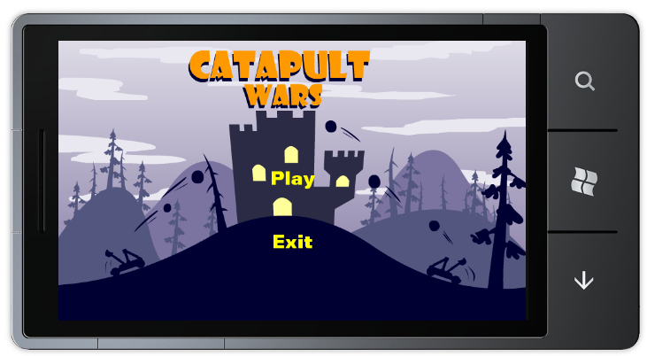
Figure 28. The game’s main menu

  - The final part of this task is to add an additional screen, the pause screen. Create a new class under the “Screens” folder and call it “PauseScreen”.
  - Open the new class file and add the following using statements at the top of the file.
C#
using GameStateManagement;
using Microsoft.Xna.Framework;
  - Change the newly created class to inherit from the “MenuScreen” class:
C#
class PauseScreen : MenuScreen
{
}
  - Add the following fields to the PauseScreen class:
C#
GameScreen backgroundScreen;
Player human;
Player computer;
bool prevHumanIsActive;
bool prevCompuerIsActive;
The purpose of the preceding fields will become evident as we implement more of the class.
  - Add the following constructor to the class:
C#
public PauseScreen(GameScreen backgroundScreen, Player human, Player computer)
: base(String.Empty)
{
IsPopup = true;

this.backgroundScreen = backgroundScreen;

// Create our menu entries.
MenuEntry startGameMenuEntry = new MenuEntry("Return");
MenuEntry exitMenuEntry = new MenuEntry("Quit Game");

// Hook up menu event handlers.
startGameMenuEntry.Selected += StartGameMenuEntrySelected;
exitMenuEntry.Selected += OnCancel;

// Add entries to the menu.
MenuEntries.Add(startGameMenuEntry);
MenuEntries.Add(exitMenuEntry);

this.human = human;
this.computer = computer;

// Preserve the old state of the game
prevHumanIsActive = this.human.Catapult.IsActive;
prevCompuerIsActive = this.computer.Catapult.IsActive;

// Pause the game logic progress
this.human.Catapult.IsActive = false;
this.computer.Catapult.IsActive = false;

AudioManager.PauseResumeSounds(false);
}
This constructor resembles that of the MainMenuScreen class, with added logic. The PauseScreen’s constructor remembers the value of each of the two players’ IsActive property, and it sets the property to false for both players. This effectively causes the game screen to freeze. Additionally, all currently playing sounds will be paused.
  - Add the following two event handlers to the class:
C#
void StartGameMenuEntrySelected(object sender, EventArgs e)
{
human.Catapult.IsActive = prevHumanIsActive;
computer.Catapult.IsActive = prevCompuerIsActive;
if (!(human as Human).isDragging)
AudioManager.PauseResumeSounds(true);
else
{
(human as Human).ResetDragState();
AudioManager.StopSounds();
}

backgroundScreen.ExitScreen();
ExitScreen();
}

protected override void OnCancel(PlayerIndex playerIndex)
{
AudioManager.StopSounds();
ScreenManager.AddScreen(new MainMenuScreen(), null);
ExitScreen();
}
Notice how the first handler, which is fired when the user wishes to return to the game, restores both player’s IsActive value and resumes all paused sounds.
  - Finally, override the “UpdateMenuEntryLocations” method to properly position the menu entries on screen:
C#
protected override void UpdateMenuEntryLocations()
{
base.UpdateMenuEntryLocations();

foreach (var entry in MenuEntries)
{
Vector2 position = entry.Position;

position.Y += 60;

entry.Position = position;
}
}
  - The final step is to revise the GameplayScreen class to utilize the new pause screen. Open GameplayScreen.cs and navigate to the “PauseCurrentGame” method. Change the method to look like this:
C#
private void PauseCurrentGame()
{
var pauseMenuBackground = new BackgroundScreen();

if (isDragging)
{
isDragging = false;
player.Catapult.CurrentState = CatapultState.Idle;
}

ScreenManager.AddScreen(pauseMenuBackground, null);
ScreenManager.AddScreen(new PauseScreen(pauseMenuBackground,
player, computer), null);
}
  - Compile and deploy the project. From the gameplay screen, you should now be able to use the back arrow key on the device to pause the game. The pause menu allows you to return to the game or exit to the main menu.
Congratulations! The game is now fully operational.

Summary
This lab introduced you to developing applications for the Windows Phone 7™ platform using the XNA Framework. In the course of this lab you created an XNA Game Studio project for Windows Phone 7, loaded the game’s resources, took care of the input, updated the game state, and added game specific logic.
By completing this hands-on lab, you also became familiar with the tools required to create and test an XNA Game Studio project for Windows Phone. In this lab, you created a new XNA Game Studio application for Windows Phone 7 using Visual Studio 2010 and the Windows Phone Developer Tools, and then created the application logic and the layout of the user interface.

